**School Management System**

**System Analysis**

1. **Recruitment Management System(Zinia)**

This system will control the overall recruitment of school.

* **Circular management system**

In this system admin of school will submit their required job circular in school front end of the web site. Here admin can edit or delete the job circular information. For job circular following information is required

* + Job Type
  + Educational Qualification
  + Required Experience
  + Salary for the job
  + Job time
* Job location
* **Application submission system**

Using this system applicant for the job will submit their application. Applicant will create their account to submit their CV or application. Applicant can edit or delete their application and can submit for another job after log in their account. For application submission the following information is required:

* Applicant Personal Information
  + - Applicant Educational Information
    - Applicant Experience Information
    - Applicant Reference Information
* Applicant Image or photo
* **Candidate selection system**
  + - Applicant ID
    - Interview Time
    - Interview Location
* Message to the Applicant
* **Confirmation management system**
  + - Applicant ID
    - Confirmation Message
* Joining Date

1. **Employee management System(Nasrin)**

This system will maintain all employees of organization. This EMS will be used for keeping records of all employees who are performing in different role within the organization. It will be updated regularly when employee will leave institution and join in institution with their responsibility. In addition, this EMS will be used to assign job responsibility each and every employee who will be reported to assigned authority or any of the upper level authority. This system also provide information, edit, delete and search facilities. Each and every employee must fill the required information of this form to ensure the active engagement in this organization.

* **Information Management System**
* Personal Information

Name

Father Name

* Mother Name
* Present Address
* Permanent Address
* Religion
* Nationality
* National ID
* Gender
* Marital Status
* Education Information
* Exam type
* Passing year
* Board or University
* Result
* Experience Information
* Company Name
* Designation
* Year
* Salary
* Reference Information
* Name
* Designation
* Address
* Contact
* Email
* Designation
* Teacher
* Accountant
* IT Specialist
* Computer Operator
* Librarian
* Job Responsibility
* Joining Date
* Reporting authority

1. **Student Management System(Yusuf)**

This system will be used for maintaining all the students within the organization. This is a system which will be used for storing information of all the students. It is mandatory fill up this form for all the students who are enrolled. This will contain personal details as well as educational information of students that will help to management ensuring the active engagement of students in all the educational activities. This system will provide edit, update, delete and search facilities of student information. This system requires the following information

* **Personal Information**
* Name
* Father’s Name
* Mother’s Name
* Present Address
* Permanent Address
* Religion
* Gender
* Date of Birth
* Place of Birth
* Blood Group
* **Education**
* Previous school name
* Reason of leaving previous school
* Result of previous school
* First Enrolled class
* Admission Date

1. **Parents Management System(Abdur Rab)**

This Student Management System will be used to maintain the relationship with guardian or parents of students. It will preserve all the information of guardian or parents so that management can use it whenever is needed to contact guardian or parents for the betterment of students. This system will provide edit, update, delete and search facilities of parent’s information. This system requires the following information

* Student ID
* Profession
* Office location
* Monthly income
* Contact
* Email
* National ID
* Passport

1. **Class Management System(Nilu)**

This system controls whole class related information .This system contains class related all information. If there is any error about class information then this system provides opportunity to edit this fault. If there any unwanted information this system helps to erases this. Class related any information can be found by this system. Required information for this system is given bellow.

* Class Time Schedule Management
* Class Name
* Section
* Number of student in each section
* Shift
  + - Class Subject
    - Class day
    - Class Time
    - Class Location
* Class Teacher ID

1. **Notice Management System(Toma)**

This system controls the notice related activity of the whole school .This system preserve all the notice of this school. This system controls which notice is for whom and when this notice will be published. This system also controls when a notice will expired. Notice related any information can be found by this system. For this system following information must be needed.

* Type
* All
* Employee
* Teacher
* Student
* Publish Date
* Expire Date
* Subject
* Description

1. **Exam Management System(Hridoy Khan)**

* Exam Type
* Class test
* Annual
* Final
* Exam Date
* Exam Time
* Class
* Department

1. **Result Management System(Josh)**

* Student ID
* Class
* Subject
* Mark
* Grade
* Year
* Date
* Exam type

1. **Account Management System(Nasrin)**

The account management system executes all account information. This system stores all account’s information. All the income expenses information depended on journal, ledgers, cash book, trial balance and Balance Sheet etc. Account management system can correct any wrong information about account. If there is any unwanted information system provides the facility to remove it. To operate this system you need the following items.

* Cash Book
* Model Header
* Date
* Description
* Reference
* Amount
* Type
* Debit
* Credit
* Trial Balance
* Serial No
* Description
* Reference
* Debit Amount
* Credit Amount
* Ledger
* Add Transection
* Date
* Description
* Reference
* Debit Amount
* Credit Amount
* Income Statement
* Add Revenue and Gains
* Description
* Amount Details
* Amount
* Add Expenses and Losses
* Description
* Amount Details
* Amount
* Balance Sheet
* Total Current Assets and Fixed Assets
* Description
* Amount
* Total Liability and Owners Equity
* Description
* Amount

1. **Admission Management System(Jack)**

All admission works are done by admission management system. The system is a global system. This system stores all admission’s information. Admission management system can correct any wrong information about admission. If there is any unwanted information system provides the facility to remove it. This system provides a search option, for searching any information about admission. Anyone can apply for admission by this system. To operate this system you need the following items.

* **Personal Information**
* Name
* Father’s Name
* Mother’s Name
* Present Address
* Permanent Address
* Religion
* Gender
* Date of Birth
* Place of Birth
* Blood Group
* **Education**
* Previous school name
* Reason of leaving previous school
* Result of previous school
* First Enrolled class
* Admission Date

1. **Attendance Management System(Iqbal)**

* Type
* Student
* Student ID
* Employee
* Employee ID
* Day
* Status
* Present
* Absent
* Entry/Exit time

1. **Leave Management System(Shimul)**

This system will control leave of school stuff. This system will store all leave information. It will also provide edit, delete and search facilities of leave information. It will check whether the stuff is allowed to get leave or not based on allocated days for leave. This system requires the following information:

* Leave Type
* Sick
* Casual
* Annual
* Leave Start Date
* Leave End Date
* Employee ID

1. **Library management system(Mahabub)**

Library Management System is completed all the tasks of library. On this system all the books detailed information and distribution information is stored. If there is any error in the information, then it can be changed through this system. If there is any unwanted information it can be deleted. We can search by any book information through this system. We can find information about whom, when, took the book, and submitted or didn’t, can be searched through this system. The following information is needed to maintain this system.

* Library attendance (opening and closing report)
* Books Information Entry Management System
* Name
* Author Name
* Publisher Name
* Quantity
* Date
* Status
* Damage
* Lost
* Issued
* Available
* On Demand
* List of books
* Book Issue Management System
* Member ID
* Book id
* Date
* Returning date
* Message Delivery Management System
* Member id
* Message
* Date
* Reason
* Over Returning Date
* Late Fee
* Others
* Library card
* Member Id
* Name
* Member Type
* Image
* Address
* Contact
* School Logo
* Card Validation Date
* Registration
* Name
* Type
* Student
* Employee
* Fee
* Username
* Password
* Image
* Address
* Contact
* Email

1. **Laboratory Management system(zinnia)**

This system stores all information of laboratory. That means it will store laboratory equipment information details, laboratory equipment distribution information details etc. If there is any error at the time of entry of information, then this system will provide edit facility. It will also provide delete facility to remove unwanted information. Using this system user can search any information regarding Laboratory. This system will provide information who did not return laboratory equipment. This system requires following information.

* Lab type
* Physics lab
* Chemistry lab
* Equipment Information
* Lab id
* Equipment id
* Equipment name
* Status
* Active
* Repair
* Lost
* Damage
* Distribution
* Student id
* Receiving Date
* Receiving time
* Submission Date
* Submission time
* Equipment id

1. **Equipment management system(yusuf)**

Equipment management system operates within schools for important departmental assets and equipment. The equipment management system includes –

1. Documented receipt and recording processes
2. Equipment management processes including stock take and loan of equipment
3. Appropriate disposal and write-off process.

Equipment management also involves dealing with issues of fraud, private and unofficial use of equipment, conflicts of interest and misuse of resources. Stock take are undertake annually to assist in identifying assets that need replacing are missing or obsolete. This system also provides edit, delete and search facilities of equipment information. This system requires the following information:

* Type
* Quantity
* Source
* Purchase
* Supplier ID
* Invoice ID
* Cost Per Item
* Total Cost
* Donate
* Name
* Description
* Date
* Status
* Active
* Damage
* Repair
* Lost
* Supplier Info
* Name
* Type
* Contact
* Email
* Address

1. **Salary management system(Rab)**

Every organization pays salary to its employee. This work is done every month and record of this activity is kept for further use. A secured and reliable system is required to handle it. This system is used to calculate and pay salary of employee each month. Feeds the details of salary paid to each grade employee with all types allowance that school providers. This system also provides edit, delete and search facilities of salary information. This system requires the following information:

* Designation
* Basic salary
* House rent
* Treatment
* Convince
* Provident fund
* Bonus
* Month
* Year
* Employee ID

1. **Event Management System(nilu)**

The process of planning and coordinating of an event is generally known as event management. This system helps us to arrange an event successfully. It stores and operates all the information about an event. In this system you can know about the previous and coming programs. This system gives you various types of opportunity such as select, delete, insert, entry etc. If there is any error, you can change it. This system gives any program related detail information. This system needs the following information:

* Types
* Cultural Program
* National program
* Annual program
* Debate program
* Re-union
* Picnic
* Rag-day
* Fresher program
* Date of event
* Location
* Time
* Interested to participate
* Student id
* Event ID
* Topic type
* Debate
* Drama
* Long jump
* Discuss
* Status
* Interested
* Selected
* Not selected

1. **Online Exam Management System(Toma)**

Online exam management system gives a chance to the students to participate online exam directly. This system provides question papers with options in specific subject with fixed time. After finishing the exam this system provides you obtained marks instantly. If there is any mistake in question or answer, it can be rectified. This system also stores student’s previous result. To operate this system you must require the following information.

* Registration
* ID
* Student ID
* User name
* Password
* Status
* Question
* ID
* Class
* Subject
* Question
* Option1
* Option2
* Option3
* Option4
* Correct answer
* Marks
* Status

**Online Exam Result**

**ID**

**Student ID**

**Question ID**

**Answer code**

**Date**

1. **Health Management System(Hridoy khan)**

Health Management System controls emergency medical treatment. This system stores information of treatment provided by School medical care. It also provides edit, delete and search of medical information. For this system following information are required:

* Emergency Medical treatment
* Student ID
* Sick reason
* Provided Treatment
* Medicine
* Doctor Advice
* Date

1. **Canteen Management System(Josh)**

This System controls all the information about Canteen. This system stores information about school canteen is leased to whom, for how many years, amount of money for lease etc. It also provides edit, delete and search facilities of canteen related information. For this System following information is:

* Leaser Name
* Duration
* Amount
* Date
* Agreement
* Contact
* Email
* Address

1. **Transport Management System(Jack)**

Transport management system stores information about the transports those carry school students. This system offers various types of facilities such as select, insert, delete, update etc. You can easily find the information about going and previous transports. This system also helps you to identify the transport type, transport’s area, and transport’s fees and transport clearance information. To operate this system you must require the following information.

* Transport id
* Transport type
* Bus
* Micro
* Van
* Area
* Driver ID
* Assistant ID
* Driver assistant Information
* Name
* Email
* Contact
* Image
* Address
* Nation id
* Transportation Fee
* Student ID
* Fee
* Date
* Status
* Paid
* Due
* Transport clearance information
* Student id
* Entry time
* Exit time
* Date

1. **Tuition Fee Management System(Iqbal)**

This system controls tuition fee of students. This system will store all tuition fee information. I t will also provide edit, delete and search facilities of tuition information. This system requires the following information:

* Student id
* Date
* Month
* Year
* Fee
* Status
* Paid
* Due

1. **Membership Management system(Shimul)**

This system controls membership of the school. It controls right of users. There can be different type of users of school. Admin can give, edit or delete rights of users using this system:

* Membership Type
* Member ID
* User Name
* Password

1. **Front End Management System(Mahabub)**

This system controls content of front end of school web site. Using this system user can edit or delete or add content at front end of web site. Such as:

* Header content Management
* Title
* Description
* Keyword
* Logo
* Favicon
* Image and Gallery Management
* Gallery
* Banner
* Slide Show Management System
* Team Member Management System
* Contact Management
* Contact details
* Google Map
* Contact Form
* Sidebar Management
* Show Notice
* News Feed
* About section Management
* About
* Event Section Management
* Event Information
* Footer Management

1. **Hostel Management System(Hridoy)**

This system can store all information regarding school hostel. Such as how many room in hostel, how many seat in each room, which student stay in which seat. It keeps information about empty sets. If there is any mistake or error, it can be rectified by this system. Unwanted information can be deleted by this system. Even it also stores student’s hostels fees and other expenses. To operate this system we need the following information.

* Admission Form
* Room management
* Room No
* Number of Bed
* Bed ID
* Seat Allocation
* Student ID
* Bed ID
* Joining Date
* Hostel Expenses
* student id
* Fee
* Month
* Year
* Date
* Meal and cost Management
* Student id
* Fee
* Month
* Year
* Date

1. **Scholarship Management System(yousuf)**

Scholarship management system show and store details about scholarship such as: Scholarship requirement, scholarship application system, scholarship published result. If there is any error in the information then it can be updated. Using this system scholarship related any information can be found. For this system following information is required:

* Scholarship declaration
* Type
* Full Waiver
* Half Waiver
* Requirement
* Full and half Waiver requirement
* Percentage of mark
* Monthly income of parents
* Other requirement
* Employee Waiver
* Scholarship Application
* Student ID
* Application Fee

1. **Security Management System(Rab)**

This is a system which will control the overall security system of school. By this system authority will collect all the information which is required to ensure the security of all the students, teachers, employees and people who are actively engaged with organizational benefits.

* Student ID
* Receiver Image
* Receiver name
* Relation
* Date
* Time

1. **Tiffin Management System(Nilu)**

This system will preserve data of all the information of all students, teachers and employees who will consider under the tiffin benefits so that authority can ensure all the concerned people get these benefits as per the rules and regulations.

* Student id
* Date
* Tiffin item

1. **Feedback Management System(Toma)**

This system is used for maintaining feedback or any complaints from concerned people. Any concerned people can send feedback by using this form and submit to authority to get the reasonable solution. Authority will evaluate it and inform them the result or remedies that will come up.

* Email
* Contact
* Subject
* Comments
* Date

**Form Analysis**

1. **Recruitment Management System**

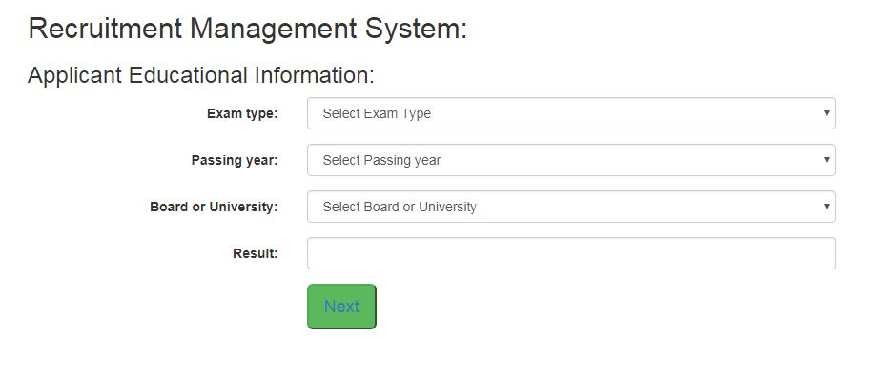

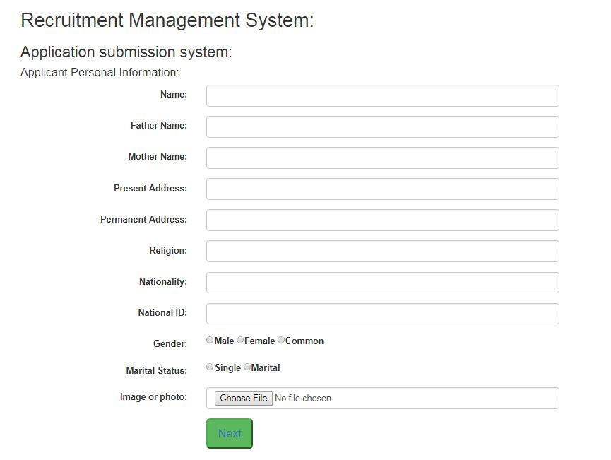

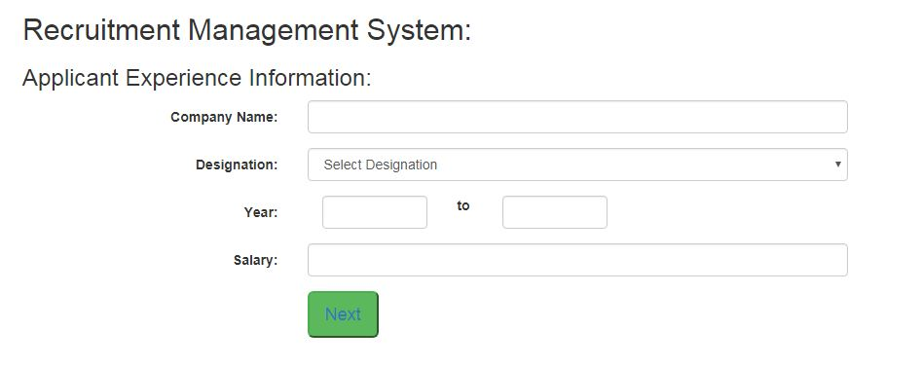

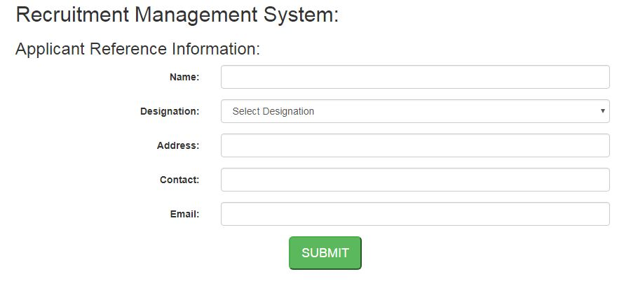

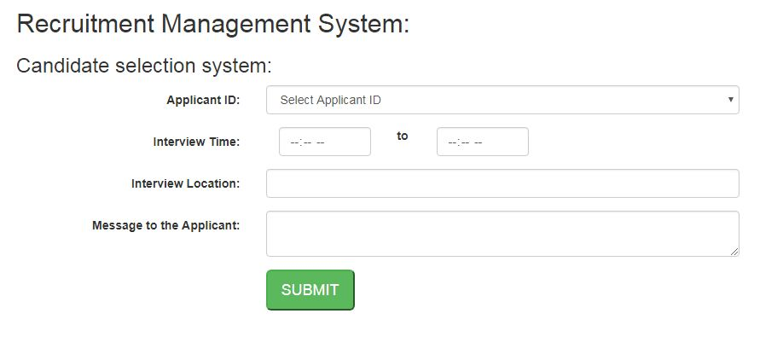

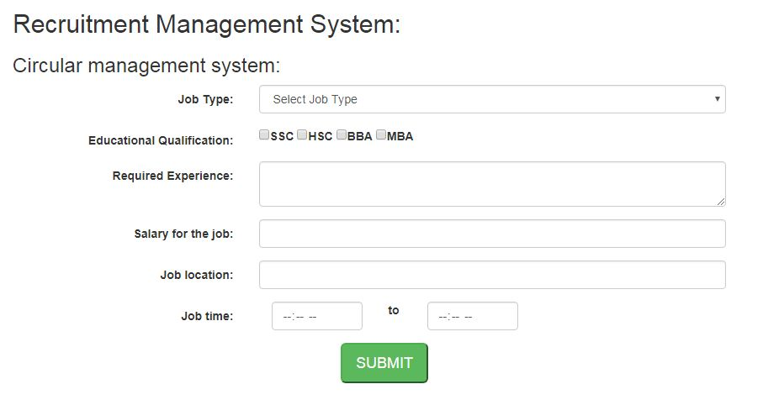

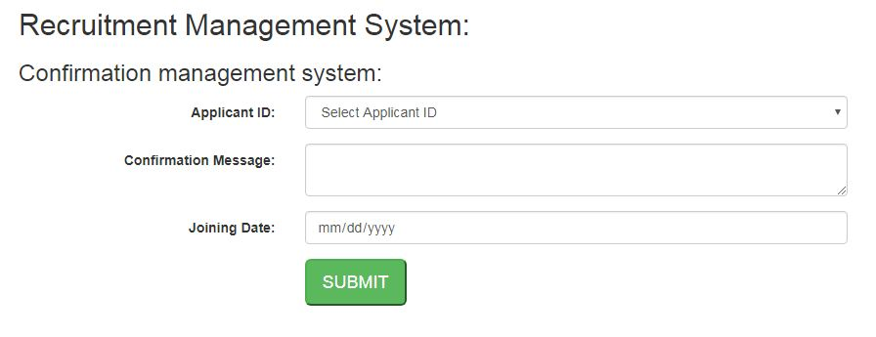

1. **Employee Management System**

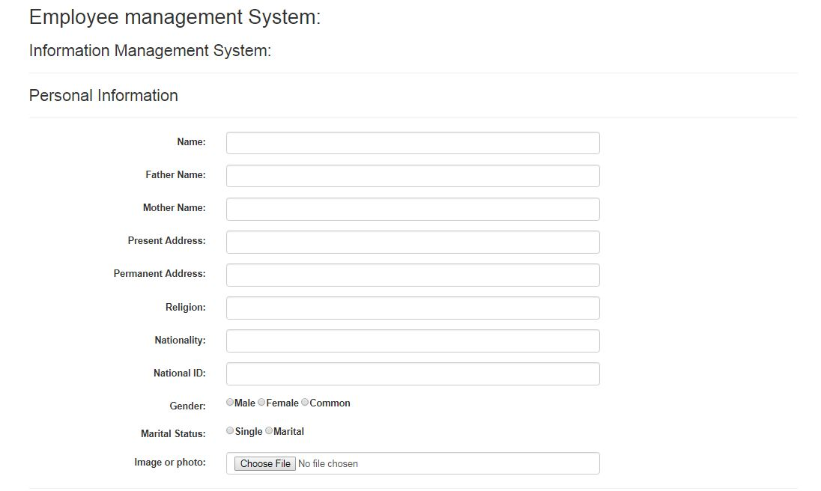

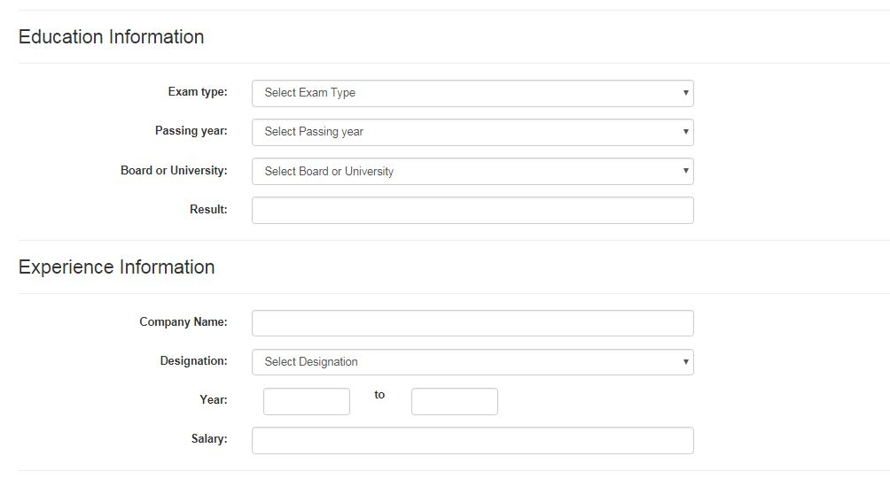

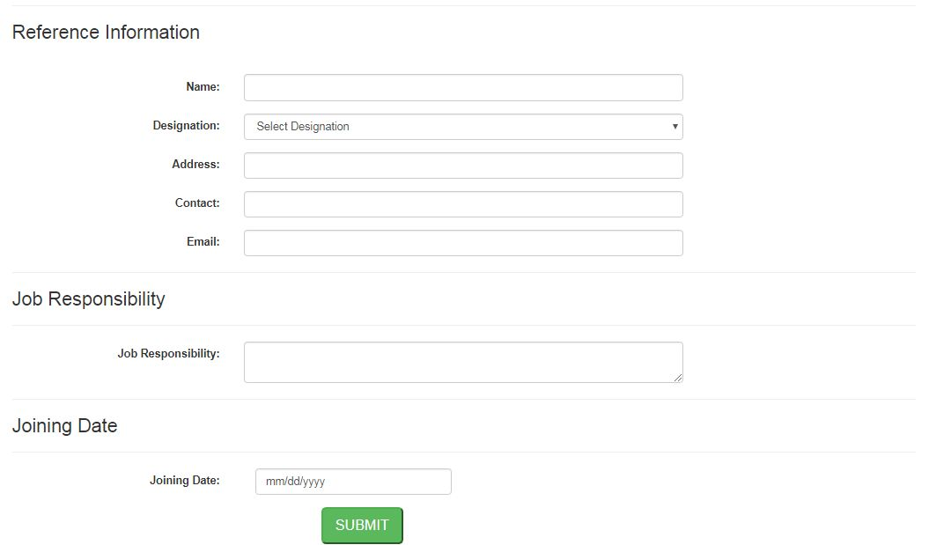

1. **Student Management System**

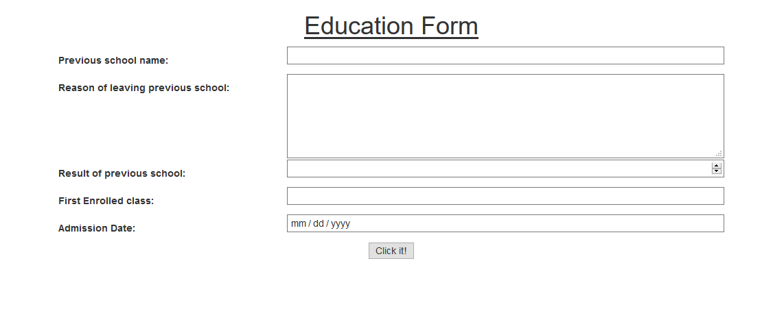

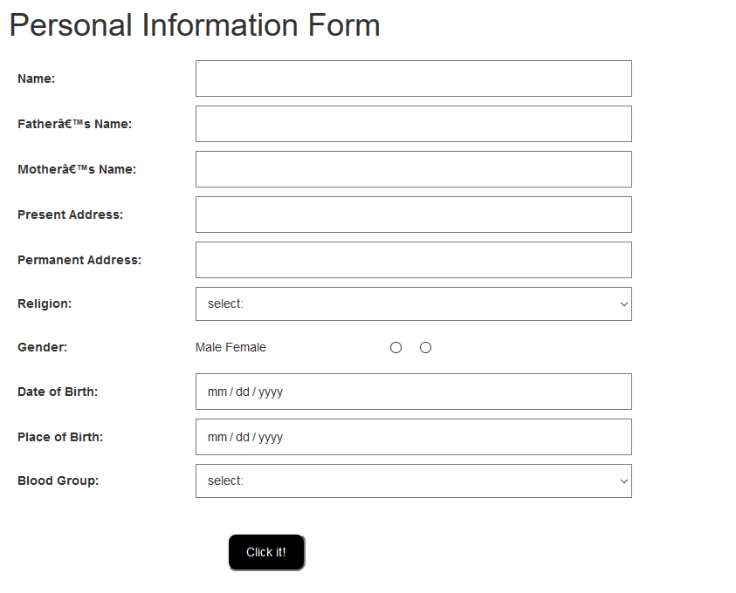

1. **Parents Management System**

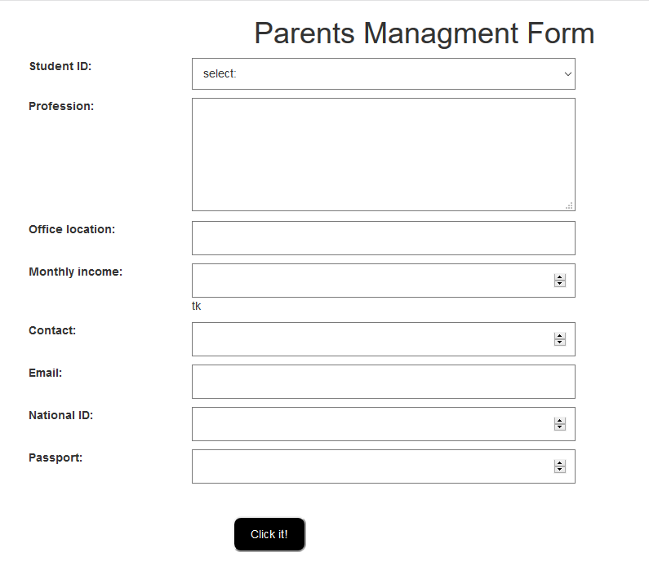

1. **Class Management System**

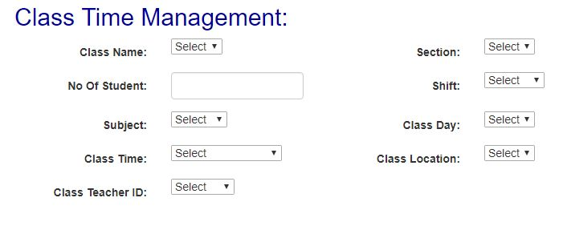

1. **Notice Management System**

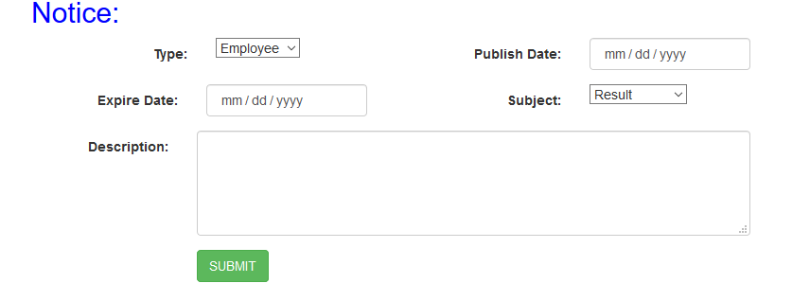

1. **Exam Management System**

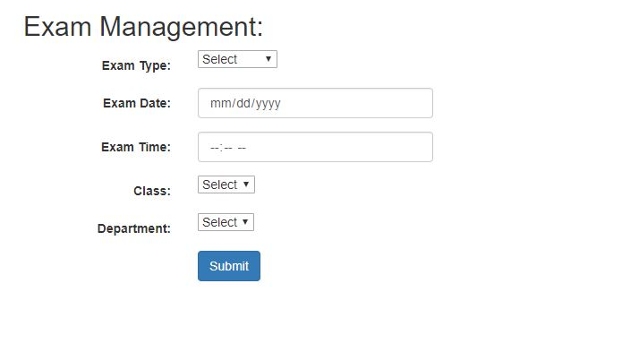

1. **Result Management System**

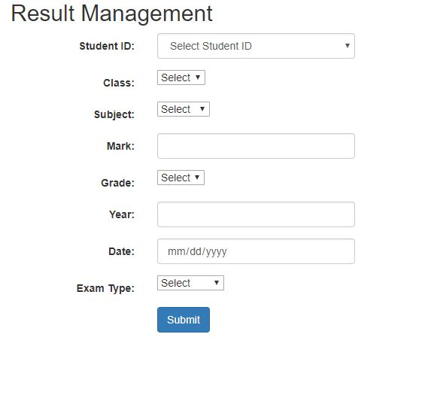

1. **Account Management System**

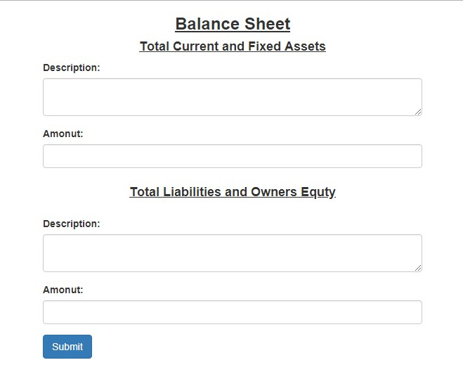

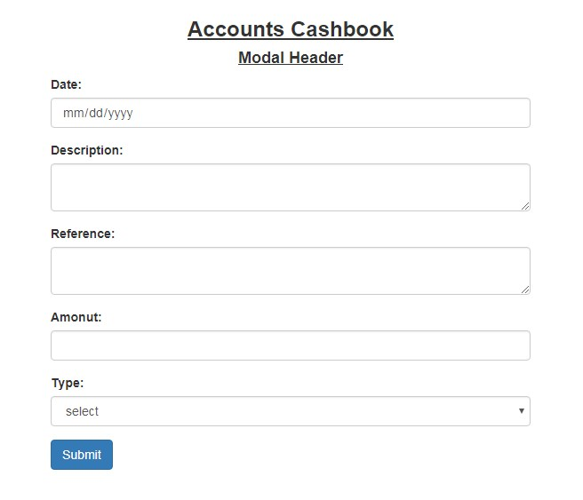

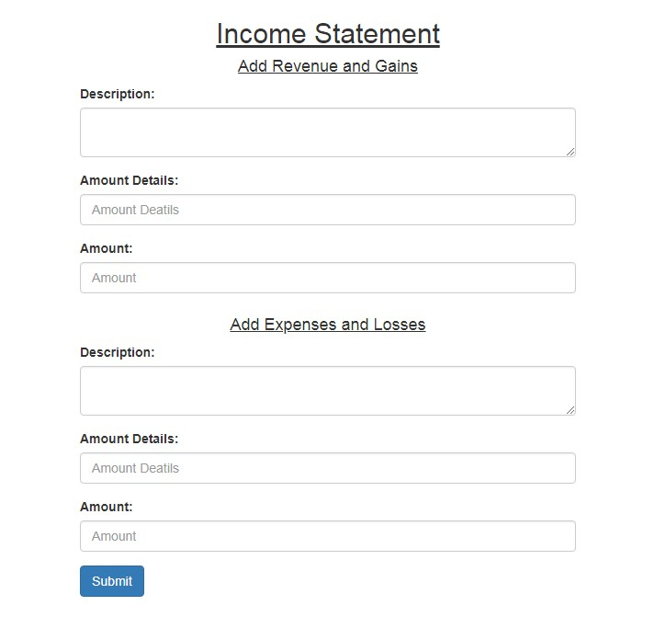

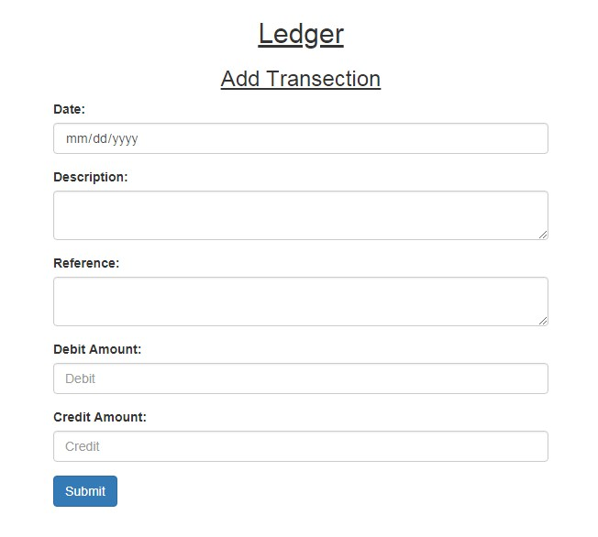

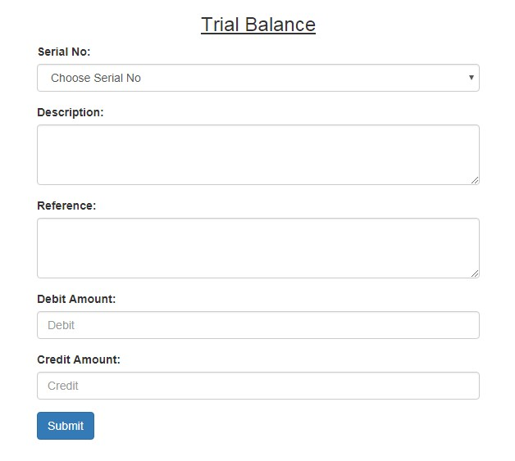

1. **Admission Management System**

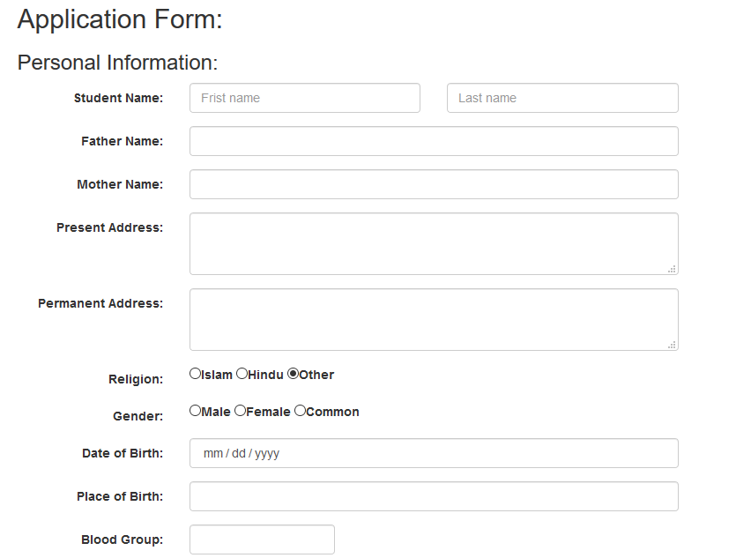

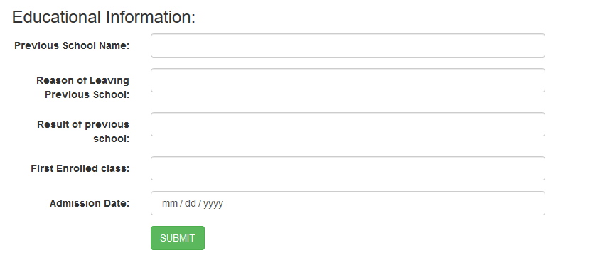

1. **Attendance Management System**

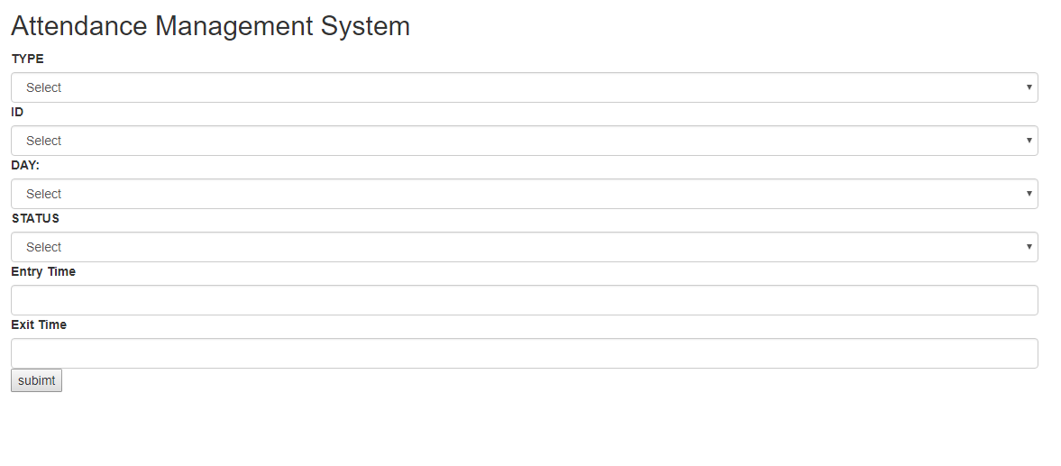

1. **Leave Management System**

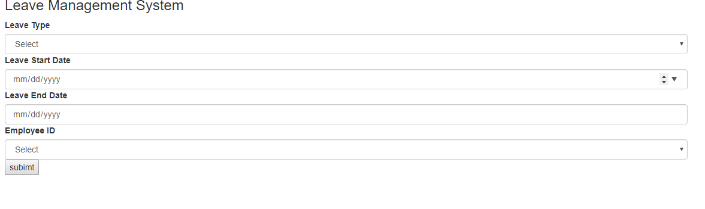

1. **Library management system**

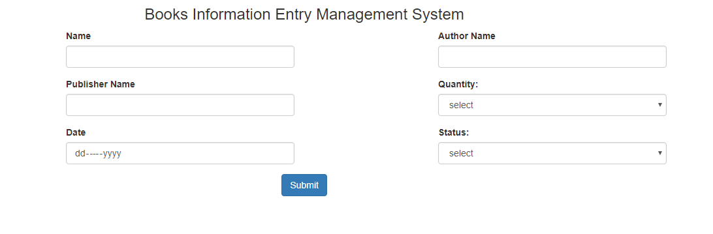

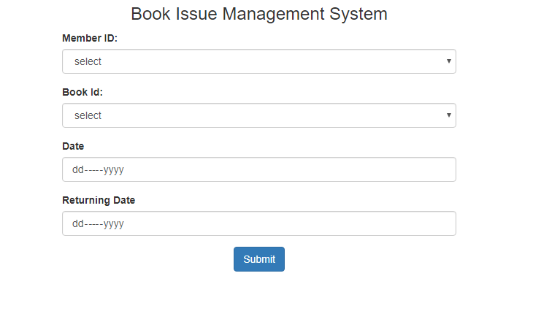

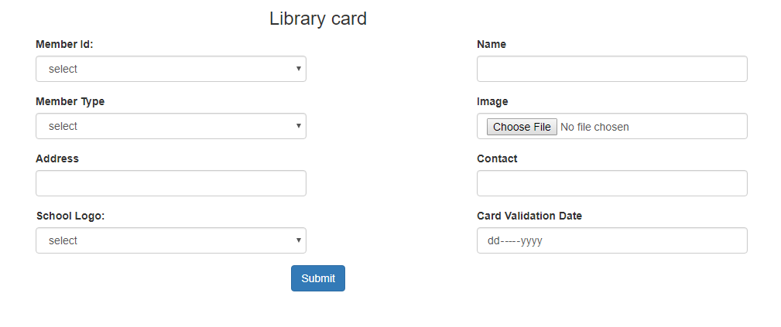

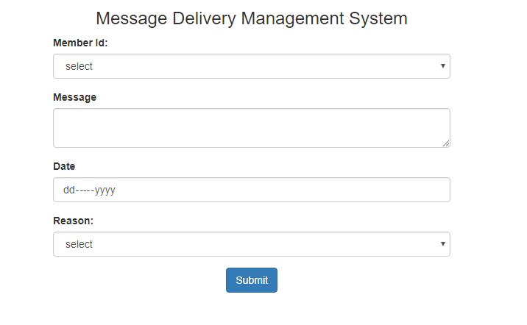

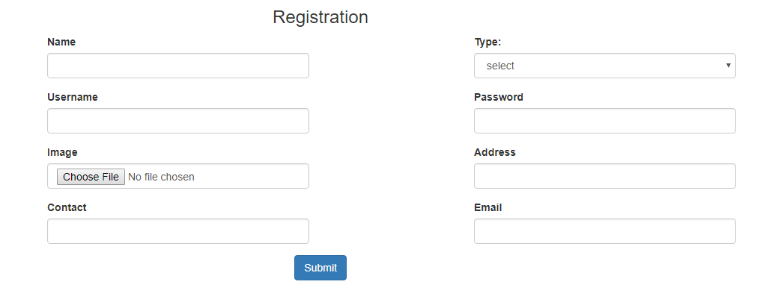

1. **Laboratory Management system**

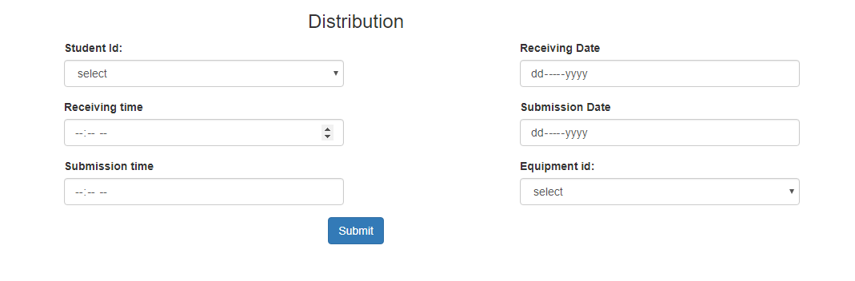

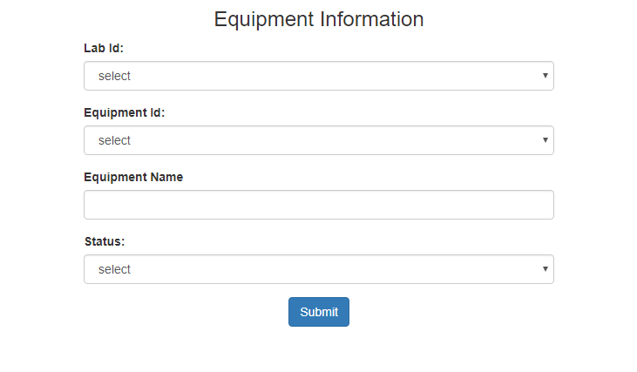

1. **Equipment management system**

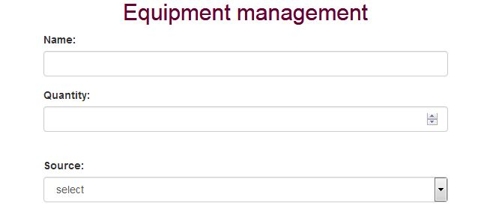

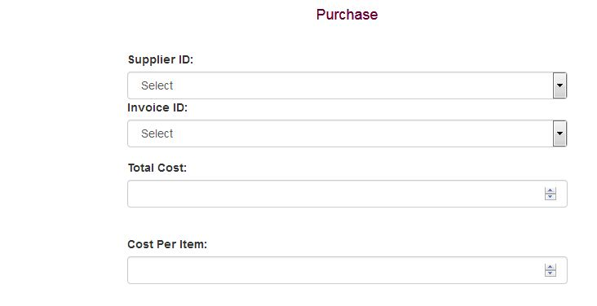

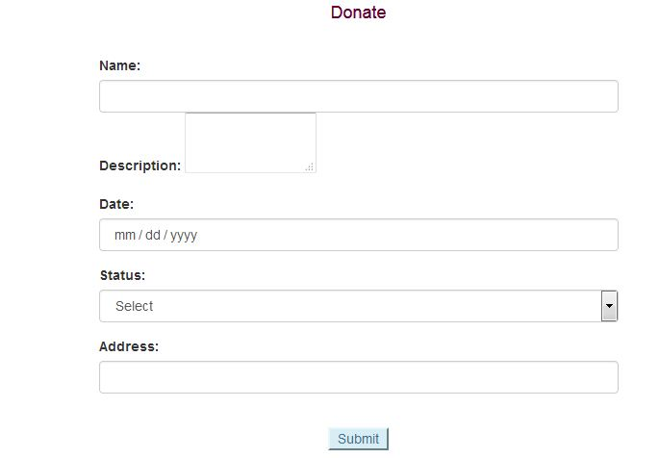

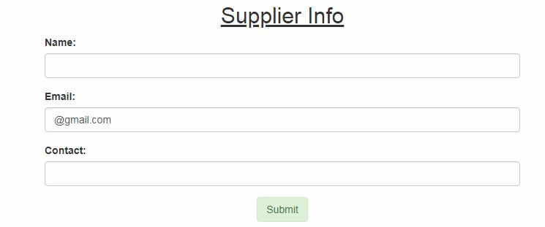

1. **Salary Management System**

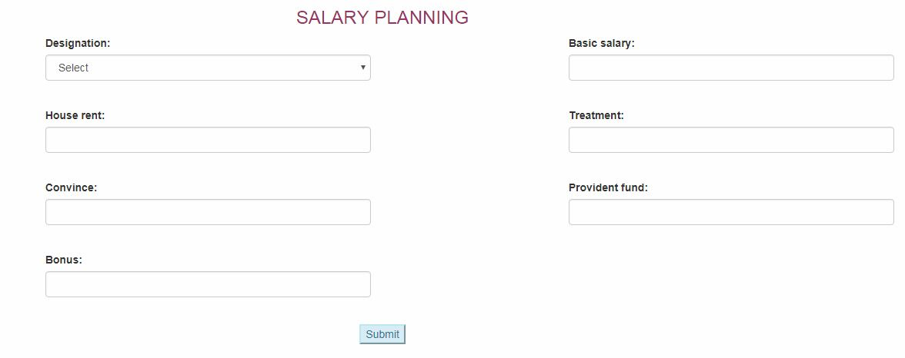

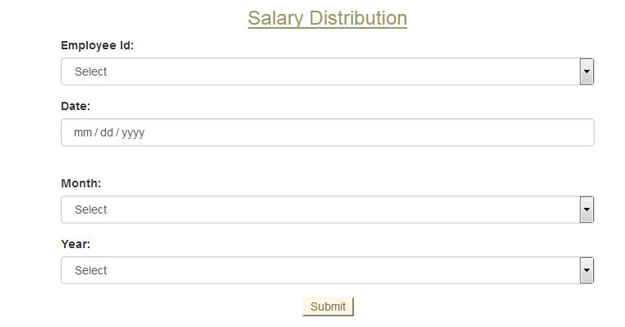

1. **Event Management System**

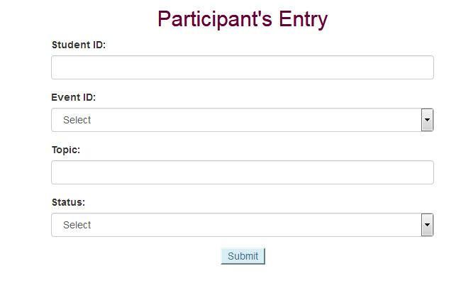

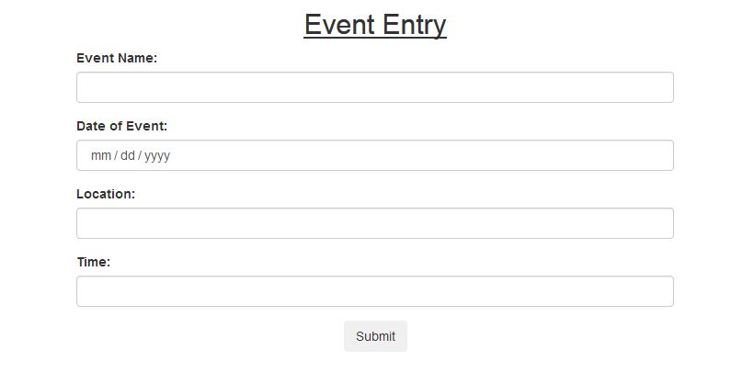

1. **Online Exam Management System**

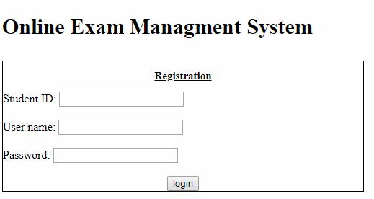

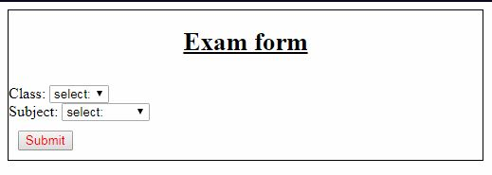

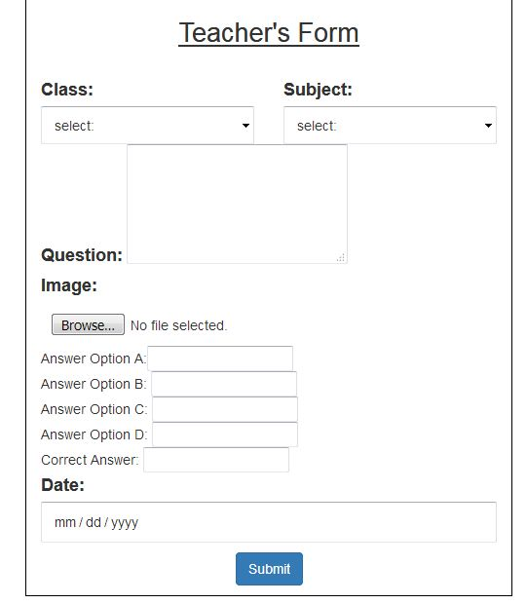

1. **Health Management System**

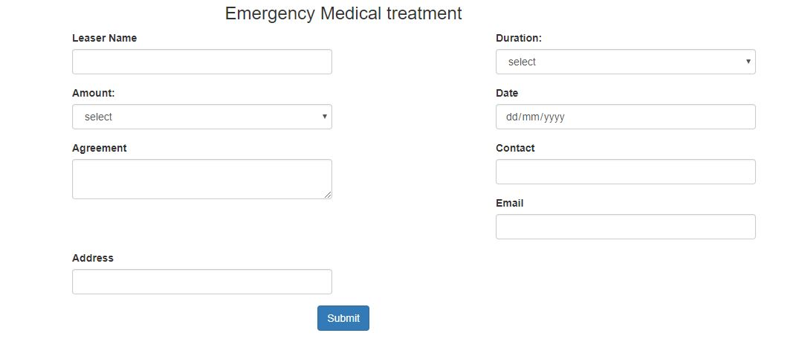

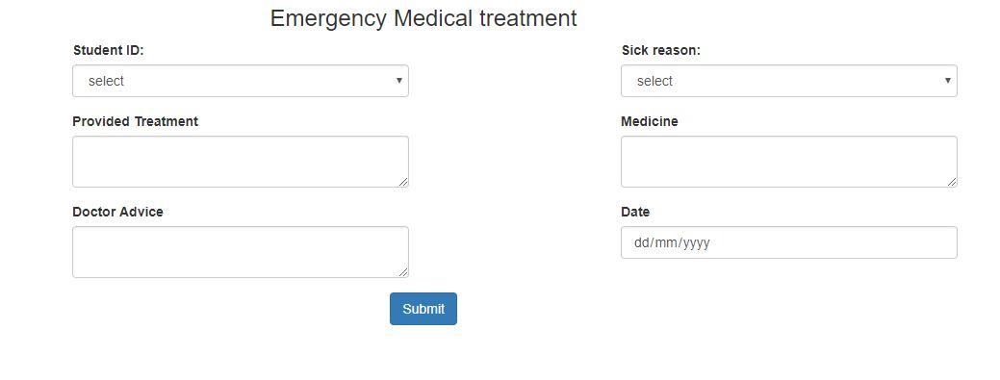

1. **Canteen Management System**

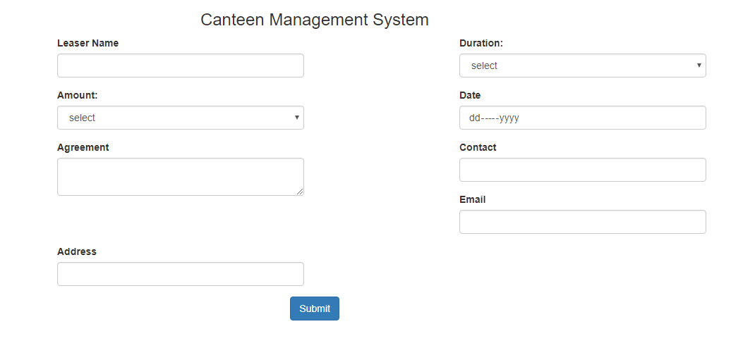

1. **Transport Management System**

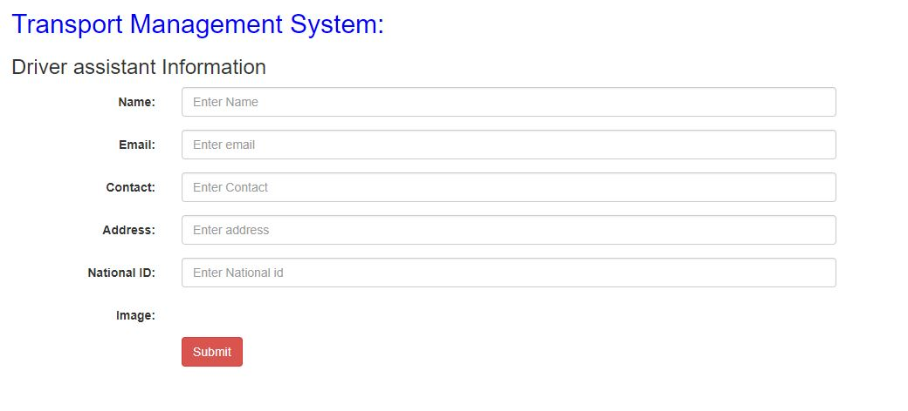

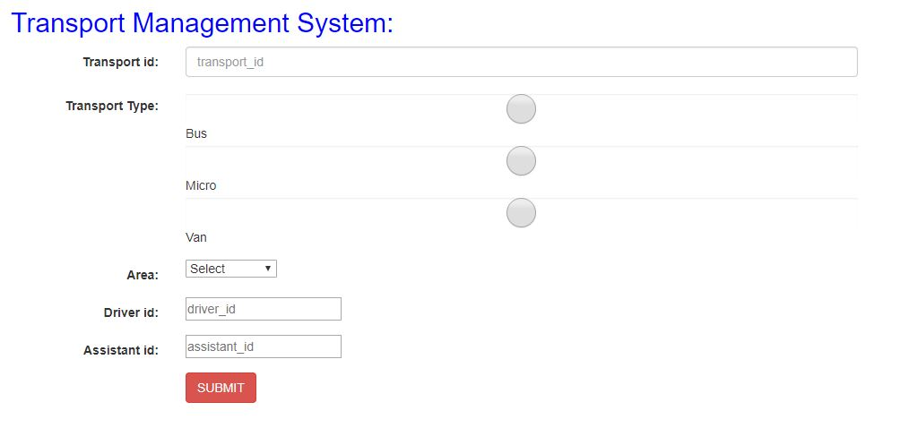

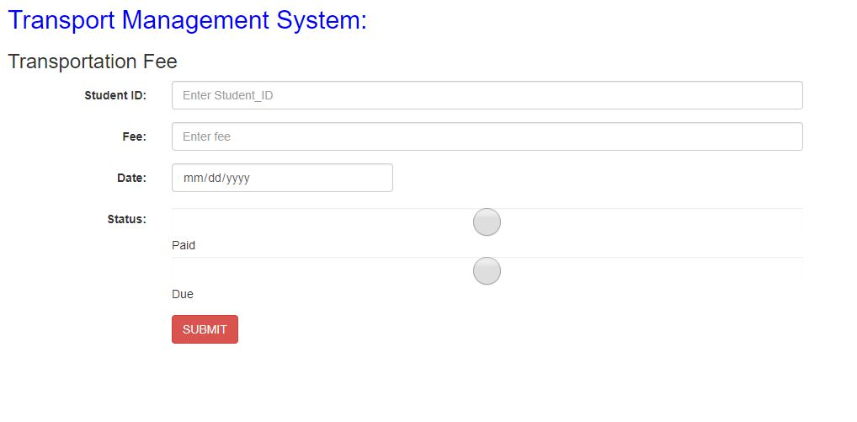

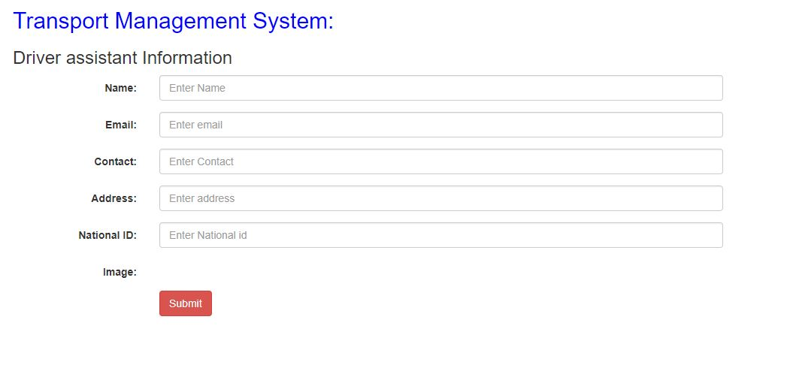

1. **Tuition Fee Management System**

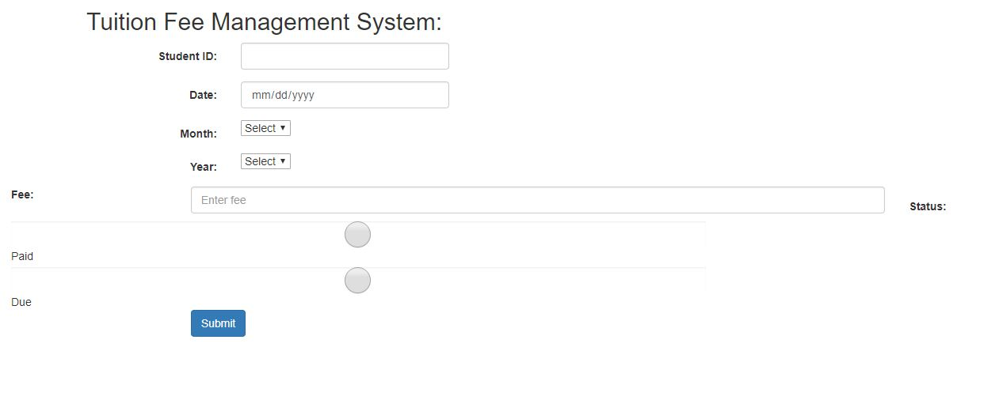

1. **Membership Management system**

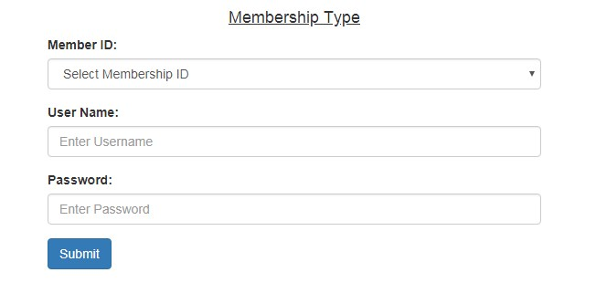

1. Not Done
2. **Hostel Management System**

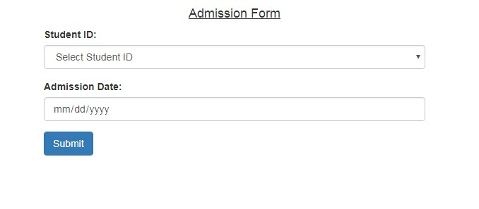

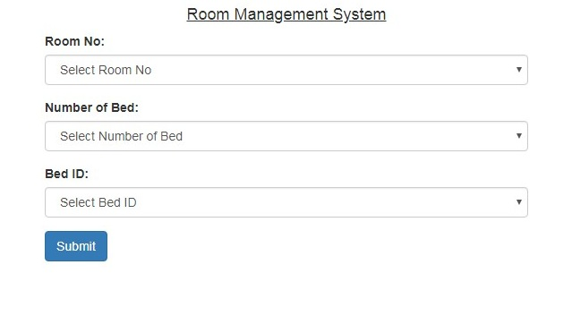

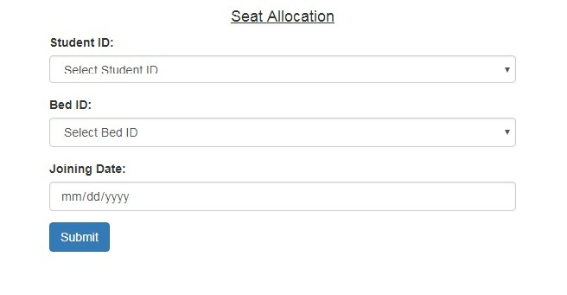

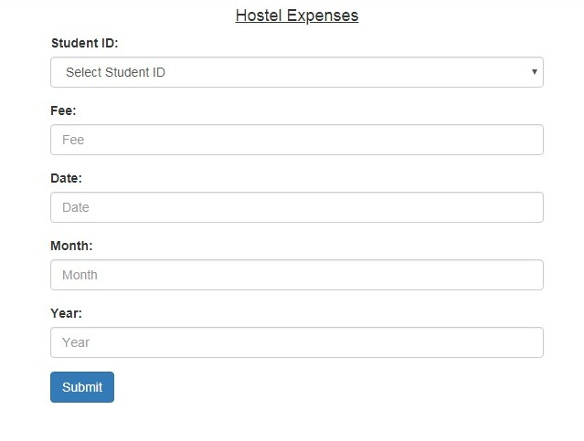

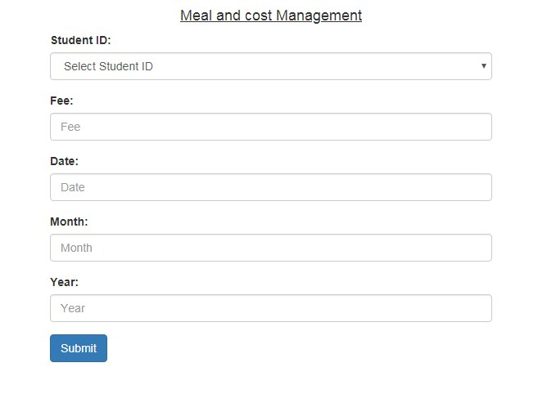

1. **Scholarship Management System**

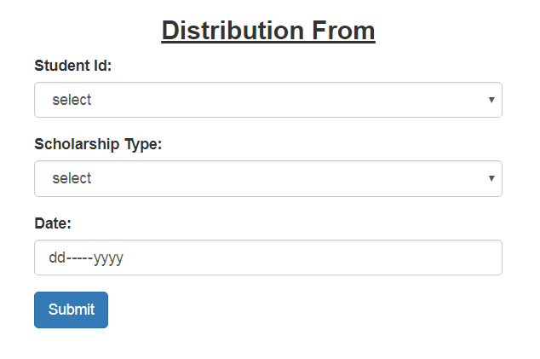

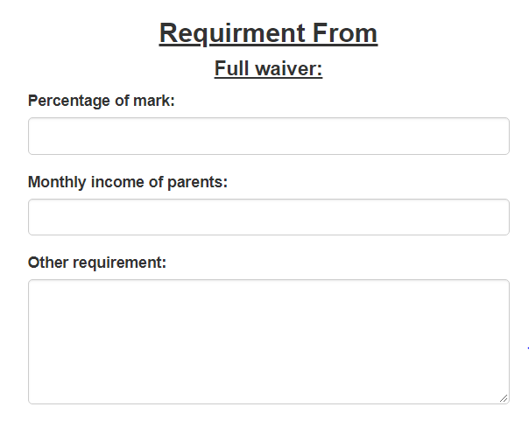

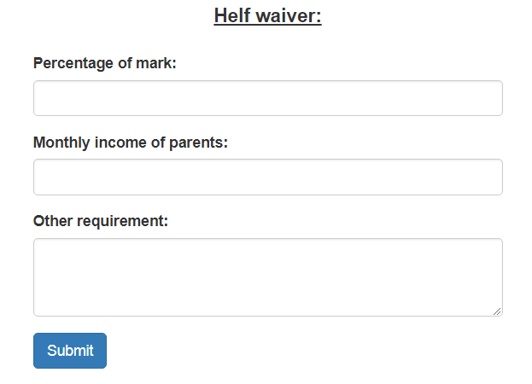

1. **Security Management System**

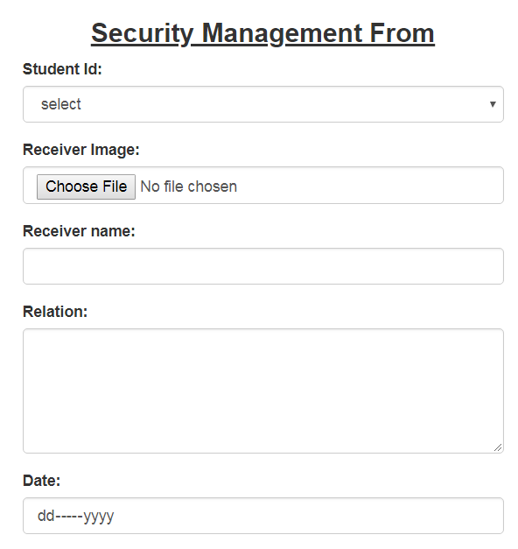

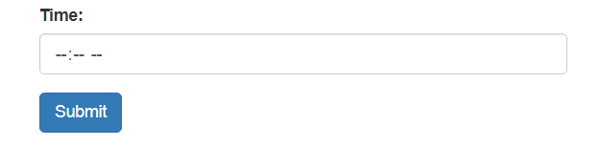

1. **Tiffin Management System**

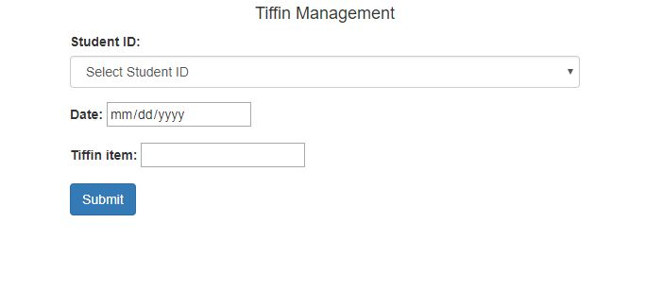

1. **Feedback Management System**

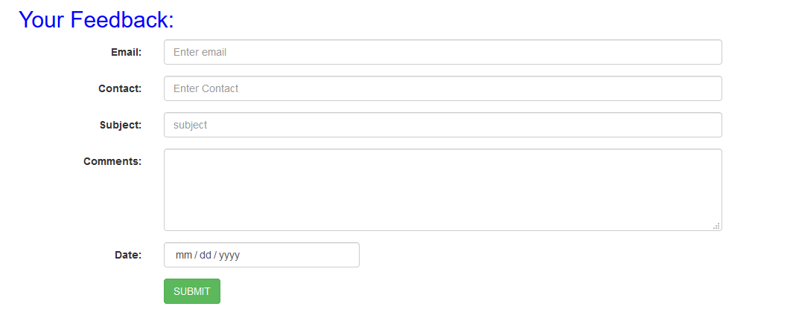

**DataBase Management System**

**Database Name: school_management**

|  |  |  |
| --- | --- | --- |
| Table name: | Related table: | Relate column name: |
| school_circular | No | No |

**Column Description: school_circular**

|  |  |  |  |  |
| --- | --- | --- | --- | --- |
| Name | Data Type | Length | Description | Default |
| id | integer | 11 | Not Null  Auto Increment  Primary Key |  |
| job_type | varchar | 20 | Not Null |  |
| educational_qualification | varchar | 20 | Not Null |  |
| required_experience | Text |  |  |  |
| job_salary | integer | 11 | Not Null |  |
| job_location | varchar | 255 | Not Null |  |
| job_time | varchar | 20 | Not Null |  |
| status | integer | 11 | Not Null |  |

1. **Circular management system**

|  |  |  |
| --- | --- | --- |
| Table name: | Related table: | Relate column name: |
| school_circular | No | No |

**Column Description: school_circular:**

|  |  |  |  |  |
| --- | --- | --- | --- | --- |
| Name | Data Type | Length | Description | Default |
| Id | Integer | 11 | Not Null  Auto Increment  Primary Key |  |
| job_type | varchar | 20 | Not Null |  |
| educational_qualification | varchar | 20 | Not Null |  |
| required_experience | Text |  |  |  |
| job_salary | integer | 11 | Not Null |  |
| job_location | varchar | 255 | Not Null |  |
| job_time | varchar | 20 | Not Null |  |
| status | Integer | 11 |  |  |

**Application submission system**

|  |  |  |
| --- | --- | --- |
| Table name: | Related table: | Relate column name: |
| school_applicant_personal_information | No | No |

**Column Description: school_applicant_personal_information:**

|  |  |  |  |  |
| --- | --- | --- | --- | --- |
| Name | Data Type | Length | Description | Default |
| Id | Integer | 11 | Not Null  Auto Increment  Primary Key |  |
| name | varchar | 30 | Not Null |  |
| father_name | varchar | 30 | Not Null |  |
| mother_name | varchar | 30 | Not Null |  |
| present_address | varchar | 255 | Not Null |  |
| permanent_address | varchar | 255 | Not Null |  |
| religion | varchar | 10 | Not Null |  |
| nationality | varchar | 50 | Not Null |  |
| national_id | varchar | 20 | Not Null |  |
| gender | varchar | 8 | Not Null |  |
| marital_status | varchar | 8 | Not Null |  |
| image | varchar | 255 | Not Null |  |
| status | Integer | 11 |  |  |

**Column Description: school_applicant_educational_information:**

|  |  |  |  |  |
| --- | --- | --- | --- | --- |
| Name | Data Type | Length | Description | Default |
| id | Integer | 11 | Not Null  Auto Increment  Primary Key |  |
| exam_type | varchar | 100 | Not Null |  |
| passing_year | Integer | 5 | Not Null |  |
| board_or_university | Text |  |  |  |
| result | varchar | 20 | Not Null |  |
| status | Integer | 11 |  |  |

**Column Description: school_applicant_experience_information:**

|  |  |  |  |  |
| --- | --- | --- | --- | --- |
| Name | Data Type | Length | Description | Default |
| id | Integer | 11 | Not Null  Auto Increment  Primary Key |  |
| company_name | varchar | 255 | Not Null |  |
| designation | varchar | 40 | Not Null |  |
| year | Integer | 5 | Not Null |  |
| salary | Integer | 11 | Not Null |  |
| status | Integer | 11 |  |  |

**Column Description: school_applicant_reference_information:**

|  |  |  |  |  |
| --- | --- | --- | --- | --- |
| Name | Data Type | Length | Description | Default |
| Id | Integer | 11 | Not Null  Auto Increment  Primary Key |  |
| name | varchar | 20 | Not Null |  |
| designation | varchar | 40 | Not Null |  |
| address | text |  |  |  |
| contact | varchar | 20 | Not Null |  |
| email | varchar | 255 | Not Null |  |
| status | Integer | 11 |  |  |

**Candidate selection system**

|  |  |  |
| --- | --- | --- |
| Table name: | Related table: | Relate column name: |
| school_candidate_selection_system | No | No |

**Column Description: school_candidate_selection_system:**

|  |  |  |  |  |
| --- | --- | --- | --- | --- |
| Name | Data Type | Length | Description | Default |
| Id | Integer | 11 | Not Null  Auto Increment  Primary Key |  |
| applicant_id | Integer | 11 | Not Null |  |
| interview_time | varchar | 10 | Not Null |  |
| interview_location | varchar | 255 | Not Null |  |
| message_applicant | text |  |  |  |
| status | Integer | 11 |  |  |

**Confirmation management system**

|  |  |  |
| --- | --- | --- |
| Table name: | Related table: | Relate column name: |
| school_confirmation_management_system | No | No |

**Column Description: school_confirmation_management_system:**

|  |  |  |  |  |
| --- | --- | --- | --- | --- |
| Name | Data Type | Length | Description | Default |
| Id | Integer | 11 | Not Null  Auto Increment  Primary Key |  |
| applicant_id | Integer | 11 | Not Null |  |
| confirmation_message | text |  |  |  |
| joining_date | varchar | 10 | Not Null |  |
| status | Integer | 11 |  |  |

1. **Employee management System:**

**Information Management System**

|  |  |  |
| --- | --- | --- |
| Table name: | Related table: | Relate column name: |
| school_information_management_system | No | No |

**Column Description: school_personal_information:**

|  |  |  |  |  |
| --- | --- | --- | --- | --- |
| Name | Data Type | Length | Description | Default |
| Id | Integer | 11 | Not Null  Auto Increment  Primary Key |  |
| name | varchar | 30 | Not Null |  |
| father_name | varchar | 30 | Not Null |  |
| mother_name | varchar | 30 | Not Null |  |
| present_address | varchar | 255 | Not Null |  |
| permanent_address | varchar | 255 | Not Null |  |
| religion | varchar | 10 | Not Null |  |
| nationality | varchar | 50 | Not Null |  |
| national_id | varchar | 20 | Not Null |  |
| gender | varchar | 8 | Not Null |  |
| marital_status | varchar | 8 | Not Null |  |
| exam_type | varchar | 100 | Not Null |  |
| passing_year | Integer | 5 | Not Null |  |
| board_or_university | Text |  |  |  |
| result | varchar | 20 | Not Null |  |
| company_name | varchar | 255 | Not Null |  |
| designation | varchar | 40 | Not Null |  |
| year | Integer | 5 | Not Null |  |
| salary | Integer | 11 | Not Null |  |
| reference_information_name | varchar | 20 | Not Null |  |
| reference_information_designation | varchar | 40 | Not Null |  |
| address | text |  |  |  |
| contact | varchar | 20 | Not Null |  |
| email | varchar | 255 | Not Null |  |
| status | Integer | 11 |  |  |

1. **Not Done**
2. **Not Done**
3. **Notice Management System:**

|  |  |  |
| --- | --- | --- |
| Table name: | Related table: | Relate column name: |
| school_notice | No | No |

**Column Description: school_notice:**

|  |  |  |  |  |
| --- | --- | --- | --- | --- |
| Name | Data Type | Length | Description | Default |
| id | integer | 11 | Not Null  Auto Increment  Primary Key |  |
| type | varchar | 20 | Not Null |  |
| publish_date | varchar | 20 | Not Null |  |
| expire_date | varchar | 30 | Not null |  |
| subject | varchar | 20 | Not Null |  |
| description | text |  | Not Null |  |

1. **Class Management System**

|  |  |  |
| --- | --- | --- |
| Table name: | Related table: | Relate column name: |
| school_class_time | No | No |

**Column Description: school_class_time**

|  |  |  |  |  |
| --- | --- | --- | --- | --- |
| Name | Data Type | Length | Description | Default |
| id | integer | 11 | Not Null  Auto Increment  Primary Key |  |
| class_name | varchar | 20 | Not Null |  |
| no_of_student | int | 11 | Not Null |  |
| section | varchar | 20 |  |  |
| shift | varchar | 20 |  |  |
| subject | varchar | 50 | Not Null |  |
| class_day | varchar | 20 | Not Null |  |
| class_time | varchar | 10 | Not null |  |
| class_location | Varchar | 10 | Not null |  |
| class_teacher_id | int | 11 | Not null |  |

1. **Exam Management System**

|  |  |  |
| --- | --- | --- |
| Table name: | Related table: | Relate column name: |
| school_exam | No | No |

**Column Description: school_exam**

|  |  |  |  |  |
| --- | --- | --- | --- | --- |
| Name | Data type | Length | Description | Default |
| id | integer | 11 | Not null  Primary key  Auto increment |  |
| exam_type | varchar | 10 | not null |  |
| exam_date | varchar | 10 | not null |  |
| exam_time | varchar | 20 | not null |  |
| class | varchar | 10 | not null |  |
| department | varchar | 50 | not null |  |
| status | integer | 11 | not null |  |

1. **Result management system**

|  |  |  |
| --- | --- | --- |
| Table name: | Related table: | Relate column name: |
| school_result | No | No |

**Column Description: school_result**

|  |  |  |  |  |
| --- | --- | --- | --- | --- |
| Name | Data type | Length | Description | Default |
| id | integer | 11 | Not null  auto increment primary key |  |
| student_id | integer | 11 | Not null |  |
| class | varchar | 20 | not null |  |
| subject | varchar | 20 | not null |  |
| mark | integer | 11 | not null |  |
| grade | varchar | 20 | not null |  |
| year | varchar | 20 | not null |  |
| date | varchar | 20 | not null |  |
| exam_type | varchar | 20 | not null |  |
| status | integer | 11 | not null |  |

1. **Account Management System**

|  |  |  |
| --- | --- | --- |
| Table name: | Related Table: | Relate Column Name: |
| school_cash_book | No | No |

**Column Description: school_cash_book:**

|  |  |  |  |  |
| --- | --- | --- | --- | --- |
| Name | Data Type | Length | Description | Default |
| id | integer | 11 | Not Null  Auto Increment  Primary Key |  |
| date | varchar | 20 | Not Null |  |
| description | text |  | Not Null |  |
| reference | text |  |  |  |
| amount | integer | 11 | Not Null |  |
| type | varchar | 20 | Not Null |  |
| status | Integer | 11 | Not Null |  |

|  |  |  |
| --- | --- | --- |
| Table name: | Related Table: | Relate Column Name: |
| school_trial_balance | No | No |

**Column Description: school_trial_balance:**

|  |  |  |  |  |
| --- | --- | --- | --- | --- |
| Name | Data Type | Length | Description | Default |
| id | integer | 11 | Not Null  Auto Increment  Primary Key |  |
| serial_no | Integer | 11 | Not Null Auto Increment |  |
| description | text |  | Not Null |  |
| reference | text |  |  |  |
| debit_amount | integer | 11 | Not Null |  |
| credit_amount | integer | 255 | Not Null |  |
| status | Integer | 11 | Not Null |  |

|  |  |  |
| --- | --- | --- |
| Table name: | Related Table: | Relate Column Name: |
| school_ledger | No | No |

**Column Description: school_ledger:**

|  |  |  |  |  |
| --- | --- | --- | --- | --- |
| Name | Data Type | Length | Description | Default |
| id | integer | 11 | Not Null  Auto Increment  Primary Key |  |
| date | varchar | 20 | Not Null |  |
| description | text |  | Not Null |  |
| reference | text |  |  |  |
| debit_amount | integer | 11 | Not Null |  |
| credit_amount | integer | 255 | Not Null |  |
| status | Integer | 11 | Not Null |  |

|  |  |  |
| --- | --- | --- |
| Table name: | Related Table: | Relate Column Name: |
| school_income_statement | No | No |

**Column Description: school_income_statement:**

|  |  |  |  |  |
| --- | --- | --- | --- | --- |
| Name | Data Type | Length | Description | Default |
| id | integer | 11 | Not Null  Auto Increment  Primary Key |  |
| date | varchar | 20 | Not Null |  |
| description | text |  | Not Null |  |
| amount_details | text |  |  |  |
| amount | integer | 11 | Not Null |  |
| status | Integer | 11 | Not Null |  |

|  |  |  |
| --- | --- | --- |
| Table name: | Related Table: | Relate Column Name: |
| school_add_expenses_and_losses | No | No |

**Column Description: school_add_expenses_and_losses**

|  |  |  |  |  |
| --- | --- | --- | --- | --- |
| Name | Data Type | Length | Description | Default |
| id | integer | 11 | Not Null  Auto Increment  Primary Key |  |
| date | varchar | 20 | Not Null |  |
| description | text |  | Not Null |  |
| reference | text |  |  |  |
| debit_amount | integer | 11 | Not Null |  |
| credit_amount | integer | 255 | Not Null |  |
| status | Integer | 11 | Not Null |  |

|  |  |  |
| --- | --- | --- |
| Table name: | Related Table: | Relate Column Name: |
| school_balance_sheet | No | No |

**School Balance Sheet Column Description:** Total Current Assets and Fixed Assets

|  |  |  |  |  |
| --- | --- | --- | --- | --- |
| Name | Data Type | Length | Description | Default |
| id | integer | 11 | Not Null  Auto Increment  Primary Key |  |
| description | text |  | Not Null |  |
| amount | integer | 11 | Not Null |  |
| status | Integer | 11 | Not Null |  |

Total Liability and Owners Equity

|  |  |  |  |  |
| --- | --- | --- | --- | --- |
| Name | Data Type | Length | Description | Default |
| id | integer | 11 | Not Null  Auto Increment  Primary Key |  |
| description | text |  | Not Null |  |
| amount | integer | 11 | Not Null |  |
| status | Integer | 11 | Not Null |  |

1. **Admission Management System**

|  |  |  |
| --- | --- | --- |
| Table name: | Related table: | Relate column name: |
| school_application_form | No | No |

**Column Description:** school_application_form

|  |  |  |  |  |
| --- | --- | --- | --- | --- |
| Name | Data Type | Length | Description | Default |
| id | int | 11 | not null  auto increment  primary key |  |
| student_name | varchar | 20 | not null |  |
| father_name | varchar | 20 | not null |  |
| mother_name | varchar | 20 | not null |  |
| present_address | text |  | not null |  |
| permanent_address | text |  | not null |  |
| religion | varchar | 20 | not null |  |
| gender | varchar | 20 | not null |  |
| date_of_birth | varchar | 20 | not null |  |
| place_of_birth | varchar | 20 | not null |  |
| blood_group | varchar | 20 | not null |  |
| previous_school_name | text |  | not null |  |
| reason_of_leaving_previous_school | text |  | not null |  |
| result_of_previous_school | varchar | 20 | not null |  |
| first_enrolled_class | varchar | 20 | not null |  |
| admission_date | varchar | 20 | not null |  |
| status | int | 11 |  |  |

1. **Admission Management System**

|  |  |  |
| --- | --- | --- |
| Table name: | Related table: | Relate column name: |
| school_attendance_management_system | No | No |

**Column Description: school_attendance**

|  |  |  |  |  |
| --- | --- | --- | --- | --- |
| Name | Data Type | Length | Description | Default |
| id | integer | 11 | Not Null  Auto Increment  Primary Key |  |
| student_id | integer | 11 | Not Null |  |
| employee_id | integer | 11 | Not Null |  |
| type | varchar | 20 | Not Null |  |
| day | varchar | 11 | Not Null |  |
| status | varchar | 20 | Not Null |  |
| entry_time | varchar | 20 | Not Null |  |
| exit-time | varchar | 20 | Not Null |  |
| status | integer | 11 | Not Null |  |

1. **Leave Management System**

|  |  |  |
| --- | --- | --- |
| Table name: | Related table: | Relate column name: |
| school_leave_management_system | No | No |

**Column Description: school_leave_management_system**

|  |  |  |  |  |
| --- | --- | --- | --- | --- |
| Name | Data Type | Length | Description | Default |
| id | integer | 11 | Not Null  Auto Increment  Primary Key |  |
| status | varchar | 20 | Not Null |  |
| leave_type | varchar | 20 | Not Null |  |
| leave_start_date | varchar | 25 | Not Null |  |
| leave_end_date | varchar | 25 | Not Null |  |
| employee_id | integer | 11 | Not Null |  |

1. **Library Management System**

|  |  |  |
| --- | --- | --- |
| Table name: | Related table: | Relate column name: |
| school_books_information_entry_system | No | No |

**Column Description: school_lib_books_info_entry_sys**

|  |  |  |  |  |
| --- | --- | --- | --- | --- |
| Name | Data Type | Length | Description | Default |
| id | integer | 11 | Not Null  Auto Increment  Primary Key |  |
| book_name | varchar | 20 | Not Null |  |
| publisher_name | varchar | 20 | Not Null |  |
| date | varchar | 15 | Not Null |  |
| author_name | varchar | 11 | Not Null |  |
| quantity | varchar | 20 | Not Null |  |
| status | varchar | 20 | Not Null |  |

**Column Description: school_books_issue_management_system**

|  |  |  |  |  |
| --- | --- | --- | --- | --- |
| Name | Data Type | Length | Description | Default |
| id | integer | 11 | Not Null  Auto Increment  Primary Key |  |
| member_id | integer | 11 | Not Null |  |
| book_id | integer | 11 | Not Null |  |
| date | varchar | 20 | Not Null |  |
| returning_date | varchar | 11 | Not Null |  |
| status | varchar | 20 | Not Null |  |

**Column Description: school_library_card**

|  |  |  |  |  |
| --- | --- | --- | --- | --- |
| Name | Data Type | Length | Description | Default |
| Id | integer | 11 | Not Null  Auto Increment  Primary Key |  |
| member_id | integer | 11 | Not Null |  |
| member_type | varchar | 20 | Not Null |  |
| address | varchar |  |  |  |
| name | varchar | 25 | Not Null |  |
| image | varchar | 20 | Not Null |  |
| contact | varchar | 15 | Not Null |  |
| card_validation_date | varchar | 20 | Not Null |  |
| status | integer | 11 | Not Null |  |

**Column Description: school_message_delivery_management_system**

|  |  |  |  |  |
| --- | --- | --- | --- | --- |
| Name | Data Type | Length | Description | Default |
| Id | integer | 11 | Not Null  Auto Increment  Primary Key |  |
| member_id | varchar | 20 | Not Null |  |
| message | varchar | 20 | Not Null |  |
| date | varchar | 10 | Not Null |  |
| reason | varchar | 11 | Not Null |  |
| status | integer | 11 | Not Null |  |

**Column Description: school_Registration_management_system**

|  |  |  |  |  |
| --- | --- | --- | --- | --- |
| Name | Data Type | Length | Description | Default |
| Id | integer | 11 | Not Null  Auto Increment  Primary Key |  |
| name | varchar | 20 | Not Null |  |
| user_name | varchar | 20 | Not Null |  |
| image | varchar | 20 | Not Null |  |
| contact | varchar | 11 | Not Null |  |
| type | varchar | 20 | Not Null |  |
| password | varchar | 20 | Not Null |  |
| address | varchar | 255 | Not Null |  |
| status | integer | 11 | Not Null |  |

1. **Laboratory management system**

|  |  |  |
| --- | --- | --- |
| Table name: | Related table: | Relate column name: |
| school_laboratory_management_system | No | No |

**Column Description: school_distribution_management_system**

|  |  |  |  |  |
| --- | --- | --- | --- | --- |
| Name | Data Type | Length | Description | Default |
| Id | integer | 11 | Not Null  Auto Increment  Primary Key |  |
| student_id | integer | 11 | Not Null |  |
| receiving_time | varchar | 20 | Not Null |  |
| submission_date | varchar | 10 | Not Null |  |
| receiviving_date | varchar | 11 | Not Null |  |
| submission_date | varchar | 15 | Not Null |  |
| equipment_id | integer | 11 | Not Null |  |
| status | integer | 11 | Not Null |  |

**Column Description: school_equipment_information_system**

|  |  |  |  |  |
| --- | --- | --- | --- | --- |
| Name | Data Type | Length | Description | Default |
| id | integer | 11 | Not Null  Auto Increment  Primary Key |  |
| lab_name | varchar | 100 | Not Null |  |
| equipment_name | varchar | 25 | Not Null |  |
| equipment_id | integer | 11 | Not Null |  |
| status | varchar | 20 | Not Null |  |

1. **Equipment Management System**

|  |  |  |
| --- | --- | --- |
| Table name: | Related table: | Relate column name: |
| school_equipment_management_system | No | No |

**Column Description: school_equipment_management_system**

|  |  |  |  |  |
| --- | --- | --- | --- | --- |
| Name | Data Type | Length | Description | Default |
| id | integer | 11 | Not Null  Auto Increment  Primary Key |  |
| name | varchar | 20 | Not Null |  |
| quantity | integer | 20 | Not Null |  |
| total_cost | integer | 30 | Not Null |  |
| date | integer | 15 | Not null |  |
| source | varchar | 25 | Not null |  |
| supplier_id | integer | 11 |  |  |
| status | integer | 11 | Not Null |  |

|  |  |  |
| --- | --- | --- |
| Table name: | Related table: | Relate column name: |
| school_supplier_info_system | No | No |

**Column Description: school_equipment_management_system**

|  |  |  |  |  |
| --- | --- | --- | --- | --- |
| Name | Data Type | Length | Description | Default |
| id | integer | 11 | Not Null  Auto Increment  Primary Key |  |
| name | varchar | 10 | Not Null |  |
| email | varchar | 20 | Not Null |  |
| contact | varchar | 15 | Not Null |  |
| status | integer | 11 | Not Null |  |

1. **Salary Managemen System**

|  |  |  |
| --- | --- | --- |
| Table name: | Related table: | Relate column name: |
| school_salary_planning_management_system | No | No |

**Column Description: school_salary_planning_management_system**

|  |  |  |  |  |
| --- | --- | --- | --- | --- |
| Name | Data Type | Length | Description | Default |
| id | integer | 11 | Not Null  Auto Increment  Primary Key |  |
| designation | varchar | 20 | Not Null |  |
| basic_salary | integer | 11 | Not Null |  |
| convince | integer | 11 |  |  |
| bonus | integer | 11 |  |  |
| House_rent | integer | 11 |  |  |
| treatment | integer | 11 |  |  |
| provident_fund | integer | 11 |  |  |
| status | integer | 11 | Not Null |  |

|  |  |  |
| --- | --- | --- |
| Table name: | Related table: | Relate column name: |
| school_salary_distribution_system | No | No |

**Column Description: school_salary_distribution_system**

|  |  |  |  |  |
| --- | --- | --- | --- | --- |
| Name | Data Type | Length | Description | Default |
| id | integer | 11 | Not Null  Auto Increment  Primary Key |  |
| employee_Id | integer | 11 | Not Null |  |
| date | integer | 11 | Not Null |  |
| month | integer | 11 | Not Null |  |
| year | integer | 11 | Not Null |  |
| status | integer | 11 | Not Null |  |

1. **Event Management System**

|  |  |  |
| --- | --- | --- |
| Table name: | Related table: | Relate column name: |
| school_event_info | No | No |

**Column Description: school_event_info**

|  |  |  |  |  |
| --- | --- | --- | --- | --- |
| Name | Data type | Length | Description | Default |
| id | integer | 11 | Not Null  Auto Increment  Primary Key |  |
| event_name | integer | 20 | Not null |  |
| date_of_event | integer | 20 | Not null |  |
| location | varchar | 20 | Not null |  |
| time | varchar | 20 | Not null |  |
| status | integer | 11 | Not null |  |

|  |  |  |
| --- | --- | --- |
| Table name: | Related table: | Relate column name: |
| school_event_participant | No | No |

**Column Description: school_event_participant**

|  |  |  |  |  |
| --- | --- | --- | --- | --- |
| Name | Data type | Length | Description | Default |
| id | integer | 11 | Not Null  Auto Increment  Primary Key |  |
| student_id | integer | 20 | Not null |  |
| event_id | integer | 20 | Not null |  |
| topic | varchar | 20 | Not null |  |
| status | integer | 11 | Not null |  |

1. **Online Exam Management System**

|  |  |  |
| --- | --- | --- |
| Table name: | Related table: | Relate column name: |
| school_online_exam_reg | No | No |

**Column Description: school_online_exam_reg**

|  |  |  |  |  |
| --- | --- | --- | --- | --- |
| Name | Data type | Length | Description | Default |
| id | integer | 11 | Not Null  Auto Increment  Primary Key |  |
| student_id | integer | 20 | Not null |  |
| user_name | varchar | 20 | Not null |  |
| password | varchar | 20 |  |  |
| status | integer | 11 | Not null |  |

|  |  |  |
| --- | --- | --- |
| Table name: | Related table: | Relate column name: |
| school_online_question | No | No |

**Column Description: school_online_question**

|  |  |  |  |  |
| --- | --- | --- | --- | --- |
| Name | Data type | Length | Description | Default |
| id | integer | 11 | Not Null  Auto Increment  Primary Key |  |
| class | varchar | 20 | Not null |  |
| subject | varchar | 20 | Not null |  |
| question | text |  | Not null |  |
| answer_option1 | varchar | 255 | Not null |  |
| answer_option2 | varchar | 255 | Not null |  |
| answer_option3 | varchar | 255 | Not null |  |
| answer_option4 | varchar | 255 | Not null |  |
| correct_answer | varchar | 255 | Not null |  |
| image | varchar | 20 |  |  |
| date | varchar | 20 | Not null |  |

|  |  |  |
| --- | --- | --- |
| Table name: | Related table: | Relate column name: |
| school_online_exam_information | No | No |

**Column Description: school_online_exam_information**

|  |  |  |  |  |
| --- | --- | --- | --- | --- |
| Name | Data type | Length | Description | Default |
| id | integer | 11 | Not Null  Auto Increment  Primary Key |  |
| class | varchar | 20 | Not null |  |
| subject | varchar | 20 | Not null |  |
| student_id | integer | 11 | Not null |  |
| marks | integer | 11 | Not null |  |
| date | varchar | 50 | Not null |  |
| status | integer | 11 | Not null |  |

1. **Health Management System**

|  |  |  |
| --- | --- | --- |
| Table name: | Related table: | Relate column name: |
| school_health | No | No |

**Column Description: school_health**

|  |  |  |  |  |
| --- | --- | --- | --- | --- |
| Name | Date Type | Length | Description | Default |
| id | integer | 11 | Not Null  Auto Increment  Primary Key |  |
| student_id | integer | 10 | Not Null |  |
| sick_reason | varchar | 255 | Not Null |  |
| provided_treatement | varchar | 255 | Not Null |  |
| medicine | varchar | 255 |  |  |
| doctor_advice | text |  |  |  |
| date | varchar | 10 | Not Null |  |
| status | integer | 11 | Not Null |  |

1. **Canteen Management System**

|  |  |  |
| --- | --- | --- |
| Table name: | Related table: | Relate column name: |
| school_canteen | No | No |

**Column Description: school_canteen**

|  |  |  |  |  |
| --- | --- | --- | --- | --- |
| Name | Date Type | Length | Description | Default |
| id | integer | 11 | Not Null  Auto Increment  Primary Key |  |
| leaser_name | varchar | 20 | Not Null |  |
| duration | varchar | 20 | Not Null |  |
| amount | integer | 20 | Not Null |  |
| date | varchar | 10 | Not Null |  |
| agreement | text | 30 | Not Null |  |
| contact | varchar | 15 | Not Null |  |
| address | varchar | 255 | Not Null |  |
| email | varchar | 30 |  |  |
| status | integer | 11 | Not Null |  |

1. **Transport Mnagement System**

|  |  |  |
| --- | --- | --- |
| Table name: | Related table: | Relate column name: |
| school_transport_management | No | No |

**Column Description: school_transport_management**

|  |  |  |  |  |
| --- | --- | --- | --- | --- |
| Name | Data Type | Length | Description | Default |
| id | int | 11 | Not Null  Auto Increment  Primary Key |  |
| transport_id | integer | 11 | Not Null  Auto Increment  Primary Key |  |
| transport_type | varchar | 20 | Not Null |  |
| area | varchar | 255 | Not Null |  |
| driver_id | integer | 11 | Not Null |  |
| assistant_id | integer | 11 | Not Null |  |
| status | integer |  | Not Null |  |

|  |  |  |
| --- | --- | --- |
| Table name: | Related table: | Relate column name: |
| school_drive_assistant_info | No | No |

**Column Description: school_drive_assistant_info**

|  |  |  |  |  |
| --- | --- | --- | --- | --- |
| Name | Data Type | Length | Description | Default |
| id | integer | 11 | Not Null  Auto Increment  Primary Key |  |
| nid | integer | 11 | Not Null  Unique |  |
| assistant_name | varchar | 20 | Not Null |  |
| assistant_email | varchar | 100 | Not Null |  |
| assistant_contact | integer | 11 | Not Null |  |
| assistant_image | varchar | 50 | Not Null |  |
| assistant_address | varchar | 255 | Not Null |  |
| status | integer |  | Not Null |  |

|  |  |  |
| --- | --- | --- |
| Table name: | Related table: | Relate column name: |
| school_transport_fee | No | No |

**Column Description: school_transport_fee**

|  |  |  |  |  |
| --- | --- | --- | --- | --- |
| Name | Data Type | Length | Description | Default |
| student_id | integer | 11 | Not Null  Auto Increment  Primary Key |  |
| transport_fee | integer | 11 | Not Null |  |
| transport_date | varchar | 10 | Not Null |  |
| transport_status | varchar | 20 | Not Null |  |
| status | integer | 11 | Not Null |  |

|  |  |  |
| --- | --- | --- |
| Table name: | Related table: | Relate column name: |
| school_transport_clearance_info | No | No |

**Column Description: school_transport_clearance_info**

|  |  |  |  |  |
| --- | --- | --- | --- | --- |
| Name | Data Type | Length | Description | Default |
| student_id | integer | 11 | Not Null  Auto Increment  Primary Key |  |
| entry_time | integer | 11 | Not Null |  |
| exit_time | varchar | 10 | Not Null |  |
| transport_date | varchar | 20 | Not Null |  |
| status | integer | 11 | Not Null |  |

1. **Tuition Fee Management System**

|  |  |  |
| --- | --- | --- |
| Table name: | Related table: | Relate column name: |
| school_tution_fee | No | No |

**Column Description: school_tution_fee**

|  |  |  |  |  |
| --- | --- | --- | --- | --- |
| Name | Data Type | Length | Description | Default |
| id | integer | 11 | Not Null  Auto Increment  Primary Key |  |
| student_id | integer | 11 | Not Null |  |
| paid_date | integer | 11 | Not Null |  |
| paid_month | integer | 10 | Not Null |  |
| paid_date | integer | 20 | Not Null |  |
| paid_year | integer | 11 | Not Null |  |
| fee_paid | integer | 11 | Not Null |  |
| paid_status | varchar | 250 | Not Null |  |
| status | integer | 11 | Not Null |  |

1. **Membership Management system**

|  |  |  |
| --- | --- | --- |
| Table name: | Related Table: | Relate Column Name: |
| school_membership_management_system | No | No |

**Column Description: school_membership_management_system**

|  |  |  |  |  |
| --- | --- | --- | --- | --- |
| Name | Data Type | Length | Description | Default |
| id | integer | 11 | Not Null  Auto Increment  Primary Key |  |
| type | varchar | 20 | Not Null |  |
| member_id | varchar | 20 | Not Null |  |
| user_name | varchar | 20 | Not Null |  |
| password | varchar | 20 | Not Null |  |
| status | Integer | 11 | Not Null |  |

1. **Not Done**
2. **Hostel Management System**

|  |  |  |
| --- | --- | --- |
| Table name: | Related Table: | Relate Column Name: |
| school_admission_form | No | No |

**Column Description: school_admission_form**

|  |  |  |  |  |
| --- | --- | --- | --- | --- |
| Name | Data Type | Length | Description | Default |
| id | integer | 11 | Not Null  Auto Increment  Primary Key |  |
| student_id | Integer | 11 | Not Null |  |
| admission_date | Varchar | 20 | Not Null |  |
| status | Integer | 11 | Not Null |  |

|  |  |  |
| --- | --- | --- |
| Table name: | Related Table: | Relate Column Name: |
| school_room_management | No | No |

**Column Description: school_room_management**

|  |  |  |  |  |
| --- | --- | --- | --- | --- |
| Name | Data Type | Length | Description | Default |
| id | integer | 11 | Not Null  Auto Increment  Primary Key |  |
| room_no | Integer | 11 | Not Null |  |
| admission_date | Varchar | 20 | Not Null |  |
| status | Integer | 11 | Not Null |  |

|  |  |  |
| --- | --- | --- |
| Table name: | Related Table: | Relate Column Name: |
| school_seat_allocation | No | No |

**Column Description: school_seat_allocation**

|  |  |  |  |  |
| --- | --- | --- | --- | --- |
| Name | Data Type | Length | Description | Default |
| id | integer | 11 | Not Null  Auto Increment  Primary Key |  |
| student_id | Integer | 11 | Not Null |  |
| bed_id | Integer | 11 | Not Null |  |
| joining_date | Varchar | 20 | Not Null |  |
| status | Integer | 11 | Not Null |  |

|  |  |  |
| --- | --- | --- |
| Table name: | Related Table: | Relate Column Name: |
| school_hostel_expenses | No | No |

**Column Description: school_hostel_expenses**

|  |  |  |  |  |
| --- | --- | --- | --- | --- |
| Name | Data Type | Length | Description | Default |
| id | integer | 11 | Not Null  Auto Increment  Primary Key |  |
| student_id | Integer | 11 | Not Null |  |
| fee | Integer | 11 | Not Null |  |
| date | Varchar | 20 | Not Null |  |
| month | Varchar | 20 | Not Null |  |
| year | Integer | 11 | Not Null |  |
| status | Integer | 11 | Not Null |  |

|  |  |  |
| --- | --- | --- |
| Table name: | Related Table: | Relate Column Name: |
| school_meal_and_cost_management | No | No |

**Column Description: school_meal_and_cost_management**

|  |  |  |  |  |
| --- | --- | --- | --- | --- |
| Name | Data Type | Length | Description | Default |
| id | integer | 11 | Not Null  Auto Increment  Primary Key |  |
| student_id | Integer | 11 | Not Null |  |
| fee | Integer | 11 | Not Null |  |
| date | Varchar | 20 | Not Null |  |
| month | Varchar | 20 | Not Null |  |
| year | Integer | 11 | Not Null |  |
| status | Integer | 11 | Not Null |  |

1. **Scholarship Management System**

|  |  |  |
| --- | --- | --- |
| Table name: | Related Table: | Relate Column Name: |
| school_scholarship_destribution | No | No |

**Column Description: school_scholarship_destribution**

|  |  |  |  |  |
| --- | --- | --- | --- | --- |
| Name | Data Type | Length | Description | Default |
| id | integer | 11 | Not Null  Auto Increment  Primary Key |  |
| student_id | integer | 11 | Not Null |  |
| scholarship_type | varchar | 20 | Not Null |  |
| date | varchar | 20 | Not Null |  |
| status | integer | 11 | Not Null |  |

|  |  |  |
| --- | --- | --- |
| Table name: | Related Table: | Relate Column Name: |
| school_scholarship_requirment_full-waiver | No | No |

**Column Description: school_scholarship_requirment_full-waiver**

|  |  |  |  |  |
| --- | --- | --- | --- | --- |
| Name | Data Type | Length | Description | Default |
| id | integer | 11 | Not Null  Auto Increment  Primary Key |  |
| percentage_of_mark | varchar | 20 | Not Null |  |
| monthly_income_of_parents | varchar | 20 | Not Null |  |
| other_requirement | varchar | 255 |  |  |
| status | integer | 11 | Not Null |  |

|  |  |  |
| --- | --- | --- |
| Table name: | Related Table: | Relate Column Name: |
| school_scholarship_requirment_half-waiver | No | No |

**Column Description: school_scholarship_requirment_half-waiver**

|  |  |  |  |  |
| --- | --- | --- | --- | --- |
| Name | Data Type | Length | Description | Default |
| id | integer | 11 | Not Null  Auto Increment  Primary Key |  |
| percentage_of_mark | varchar | 20 | Not Null |  |
| monthly_income_of_parents | varchar | 20 | Not Null |  |
| other_requirement | varchar | 255 |  |  |
| status | integer | 11 | Not Null |  |

1. **Security Management System**

|  |  |  |
| --- | --- | --- |
| Table name: | Related Table: | Relate Column Name: |
| school_security_management_info | No | No |

**Column Description: school_security_management_info**

|  |  |  |  |  |
| --- | --- | --- | --- | --- |
| Name | Data Type | Length | Description | Default |
| id | integer | 11 | Not Null  Auto Increment  Primary Key |  |
| student_id | integer | 11 | Not Null |  |
| receiver_image | varchar | 20 | Not Null |  |
| receiver_name | varchar | 20 | Not Null |  |
| relation | varchar | 20 |  |  |
| status | integer | 11 | Not Null |  |

|  |  |  |
| --- | --- | --- |
| Table name: | Related Table: | Relate Column Name: |
| school_security_receiver_info | No | No |

**Column Description: school_security_receiver_info**

|  |  |  |  |  |
| --- | --- | --- | --- | --- |
| Name | Data Type | Length | Description | Default |
| id | integer | 11 | Not Null  Auto Increment  Primary Key |  |
| student_id | integer | 11 | Not Null |  |
| receiver_id | integer | 11 | Not Null |  |
| date | varchar | 20 | Not Null |  |
| time | varchar | 20 | Not null |  |
| status | integer | 11 | Not Null |  |

1. **Tiffin Management System**

|  |  |  |
| --- | --- | --- |
| Table name: | Related Table: | Relate Column Name: |
| school_tiffin | No | No |

**Column Description: school_security_receiver_info**

|  |  |  |  |  |
| --- | --- | --- | --- | --- |
| Name | Data type | Length | Description | Default |
| id | integer | 11 | Not null  auto increment primary key |  |
| student_id | integer | 11 | Not null |  |
| date | varchar | 20 | not null |  |
| tiffin_item | varchar | 10 | not null |  |
| status | integer | 11 | not null |  |

1. **Feedback Management System**

|  |  |  |
| --- | --- | --- |
| Table name: | Related Table: | Relate Column Name: |
| School_feedback | No | No |

**Column Description: school_feedback**

|  |  |  |  |  |
| --- | --- | --- | --- | --- |
| **Name** | **Data Type** | **Length** | **Description** | **Default** |
| id | int | 11 | not null  auto increment  primary key |  |
| email | text |  | not null |  |
| contact | varchar | 20 | not null |  |
| subject | varchar | 20 | not null |  |
| comments | text |  | not null |  |
| date | varchar |  | not null |  |
| status | int | 11 | not null |  |